

PROJECT REPORT

GreyB Shoes Store

|  |  |
| --- | --- |
| **Semester:** | Web Apps Development |
| **Class:** | WD06 |
| **Group:** | Group 4 |
| **Instructor** | Vu Tran Lam |
| **Team members:** | Vu Xuan Thanh  Luu Xuan Thong  Nguyen Hong Son |

Table Content

Grey B – Shoes Store [1](https://docs.google.com/document/d/1v1ND-pvrDq94Uz5ksC13BPhkhID2i57M/edit#heading=h.30j0zll)

[Table Content 2](https://docs.google.com/document/d/1v1ND-pvrDq94Uz5ksC13BPhkhID2i57M/edit#heading=h.1fob9te)

[I. Project Introduction 3](https://docs.google.com/document/d/1v1ND-pvrDq94Uz5ksC13BPhkhID2i57M/edit#heading=h.2et92p0)

[II. Analyze System Requirements](https://docs.google.com/document/d/1v1ND-pvrDq94Uz5ksC13BPhkhID2i57M/edit#heading=h.3dy6vkm) 4

[III.   Design Details](https://docs.google.com/document/d/1v1ND-pvrDq94Uz5ksC13BPhkhID2i57M/edit#heading=h.4d34og8) 46

[IV.   Test](https://docs.google.com/document/d/1v1ND-pvrDq94Uz5ksC13BPhkhID2i57M/edit#heading=h.2s8eyo1) 81

[V. Assign Work To Each Team Member 89](https://docs.google.com/document/d/1v1ND-pvrDq94Uz5ksC13BPhkhID2i57M/edit#heading=h.4i7ojhp)

[VI.   Installation Instructions 71](https://docs.google.com/document/d/1v1ND-pvrDq94Uz5ksC13BPhkhID2i57M/edit#heading=h.2xcytpi)

[Appendix 81](https://docs.google.com/document/d/1v1ND-pvrDq94Uz5ksC13BPhkhID2i57M/edit#heading=h.1ci93xb)

[Terms and abbreviations 81](https://docs.google.com/document/d/1v1ND-pvrDq94Uz5ksC13BPhkhID2i57M/edit#heading=h.3whwml4)

[Document Format 82](https://docs.google.com/document/d/1v1ND-pvrDq94Uz5ksC13BPhkhID2i57M/edit#heading=h.2bn6wsx)

1. **Project Introduction**
   * Website that sells and recommends products for sneakers, backpacks, and other accessories
   * User (customer) accesses the website to view, search and purchase
2. Proposed system
   * Create a system for selling and recommending products for sneakers, and some other accessories
   * Help customers buy and learn more about sneakers, backpacks, and accessories
   * Easy to use
3. Scope of applicable project
   * For all customers
   * Accessible by all smart devices connected to the network
4. System Name

GreyB Shoes Store

1. Deployment Environment

* Hardware: Computer systems (pc, laptop), chip i5, ram 8G
* Software:

+ Operating system: Windows 10

1. Development Tools

* Draw.io, Visual Studio Code, Xampp

1. Customer Requirements

* Customer: Register, Login, Update information, Search product, Add to cart, Order, Cancel order.
* Admin: Login, Manage customer ,Manage order, Manage product, Manage category, Manage brand, Manage size, Manage Website, Manage coupons
* Guest: Add to cart, Order, Cancel order

1. **Analyze System Requirements**
2. Use Case

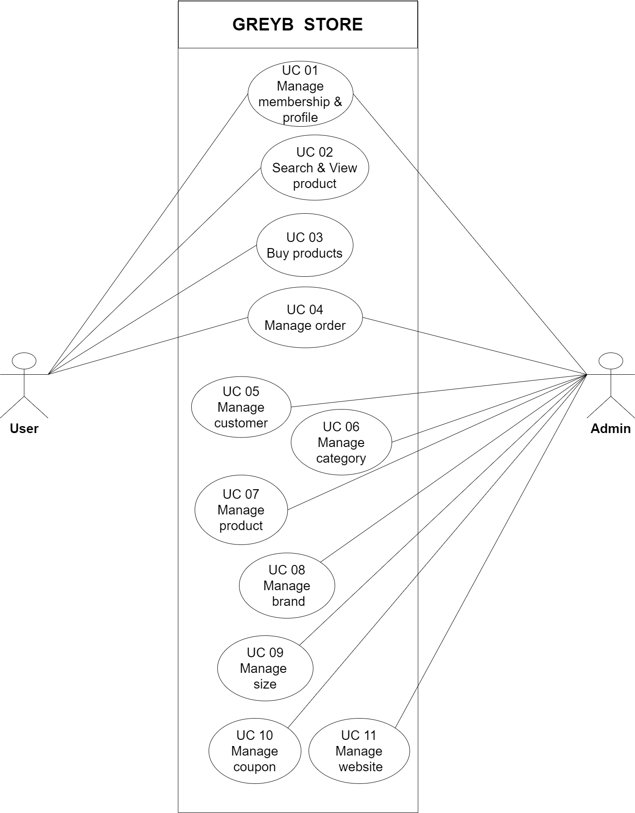

1. Use Case Descripton

* Customer
  1. Manage membership & profile – UC 01

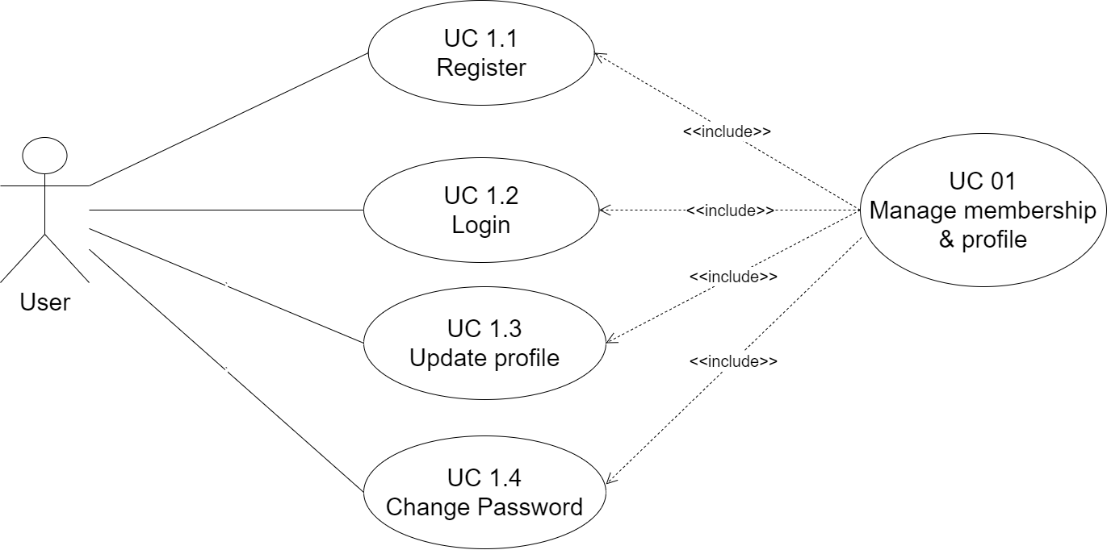

* + 1. Register – UC 1.1

|  |  |
| --- | --- |
| Use Case Name | Register |
| Use Case ID | UC 1.1 |
| Description | Allows users to create new accounts |
| Actor | Customer |
| Organizational Benefits | Attract users to use the website, help the store easily manage and update user information |
| Triggers | User selects 'Create new account' |
| Preconditions | User chooses to login but does not have an account |
| Postconditions | User successfully created new account |
| Main Course | 1. The system redirects to the account creation page  2. User enters registration information  3. System for checking and confirming registration information (EX1)  4. The system will display a successful registration message and return to the homepage |
| Alternate Courses |  |
| Exceptions | Ex1: Account already exists: When an account already exists in the database  1. The system displays a notification 'account already exists' and displays the registration screen again  2. Return to step 2 of the Main Course |

* + 1. Login – UC 1.2

|  |  |
| --- | --- |
| Use Case Name | Login |
| Use Case ID | UC 1.2 |
| Description | User has an account and wants to log in to purchase |
| Actor | Customer |
| Triggers | User selects the account icon on the website |
| Preconditions | User already has an account |
| Postconditions | User successfully logged in |
| Main Course | 1. User selects the account icon on the website  2. User enter Email and password  3. The system authenticates the login information successfully (see EX1)  4. The system redirects to the homepage |
| Alternate Courses |  |
| Exceptions | Ex 1: The system has failed login credentials and displays an error message  1. Return to step 2 of the Main Course |

* + 1. Update profile

|  |  |
| --- | --- |
| Use Case Name | Update profile |
| Use Case ID | UC 1.3 |
| Description | Allow users to modify personal information in the database |
| Actor | Customer |
| Triggers | User changes personal information |
| Preconditions | The user has logged into the website |
| Postconditions | Notice of successful information update |
| Main Course | 1. User enters information to edit  2. The system checks and confirms entered information (see EX1)  3. The system displays user information after updating |
| Exceptions | EX1. Invalid information authentication system  1. Return to step 1 of the Main Course |

* + 1. Change password

|  |  |
| --- | --- |
| Use Case Name | Change password |
| Use Case ID | UC 1.4 |
| Description | Allow users to modify personal information in the database |
| Actor | Customer |
| Triggers | User selects 'Change Password' |
| Preconditions | The user has logged into the website |
| Postconditions | Notice of successful password change |
| Main Course | 1. User enters old password and new password to change  2. The system checks and confirms entered information (see EX1)  3. The system displays user information after updating |
| Exceptions | EX1. Invalid information authentication system  1. Return to step 1 of the Main Course |

* 1. Search & View product – UC 02

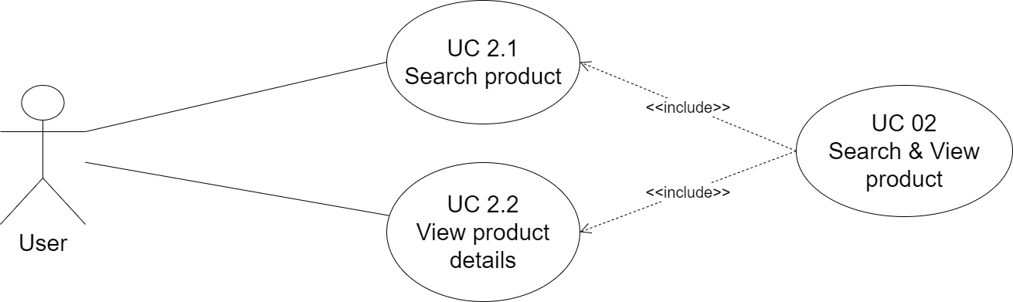

|  |  |
| --- | --- |
| Use Case Name | Search & views products |
| Use Case ID | UC 02 |
| Description | Users search and view details product information |
| Actor | Customer |
| Triggers | Users want to search for products |
| Preconditions | The user enters the product name in the search bar |
| Postconditions | - The system displays a list of searched products  - If the user selects "View details", the system displays detailed information about the selected product |
| Main Course | 1. Enter the name of the product you want to search for  2. The system validates input information.  3. Displays a list of all similar products with the same search name  (see EX1)  4. Users choose to view a product's details (see AC1)  5. The system displays detailed product parameters |
| Alternate Courses | AC1. User wants to order now  1. See “Buy product” Use Case |

* 1. Buy product – UC 03

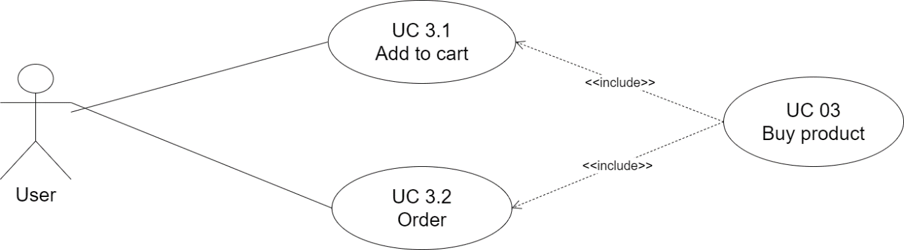

* + 1. Add to cart

|  |  |
| --- | --- |
| Use Case Name | Add to cart |
| Use Case ID | UC 3.1 |
| Description | User stores viewed products to cart |
| Actor | Customer |
| Triggers | User selects purchase |
| Preconditions | User chooses add to cart option |
| Postconditions | The system displays the message successfully added to the cart |
| Main Course | 1. The system confirms product information to add to cart  2. The system displays the message successfully added to the cart |
| Exceptions |  |

* + 1. Order

|  |  |
| --- | --- |
| Use Case Name | Order |
| Use Case ID | UC 3.2 |
| Description |  |
| Actor | Customer |
| Triggers | User selects purchase |
| Preconditions | User chooses add to cart option |
| Postconditions | The system displays the message successfully added to the cart |
| Main Course | 1. The system confirms product information to add to cart  2. The system displays the message successfully added to the cart |
| Exceptions |  |

* 1. Manage order – UC 04

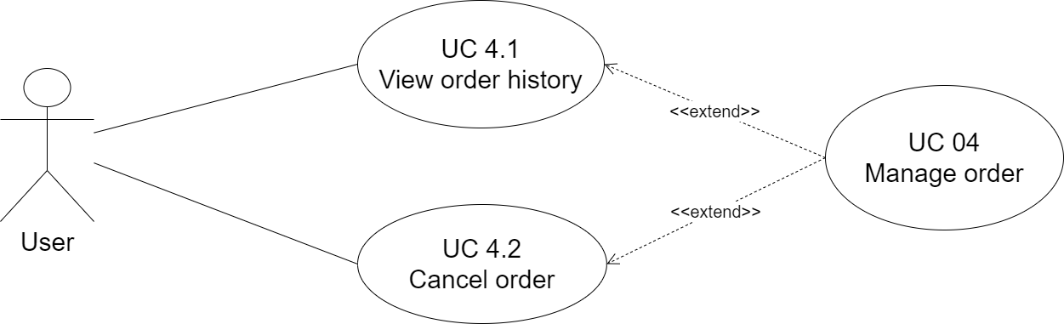

* + 1. View order history

|  |  |
| --- | --- |
| Use Case Name | View order history |
| Use Case ID | UC 4.1 |
| Description | View order history |
| Actor | Customer |
| Triggers | User selects "Manage Orders" |
| Preconditions | User login into Website from Customer |
| Postconditions | User view history of orders placed |
| Main Course | 1. Manage orders  2. The system displays a list of orders placed |
| Exceptions |  |

* + 1. Cancel order

|  |  |
| --- | --- |
| Use Case Name | Cancel order |
| Use Case ID | UC 4.2 |
| Description | User can cancel the order placed |
| Actor | Customer |
| Triggers | User selects "Cancel order" button |
| Preconditions | User login into Website from Customer |
| Postconditions | The user has successfully canceled the desired order |
| Main Course | 1. Cancel order  2. The system sends a confirmation to cancel the order  3. User confirms order cancellation  4. Successful cancellation notification system |
| Exceptions |  |

* Admin
  1. Manage customer – UC 05

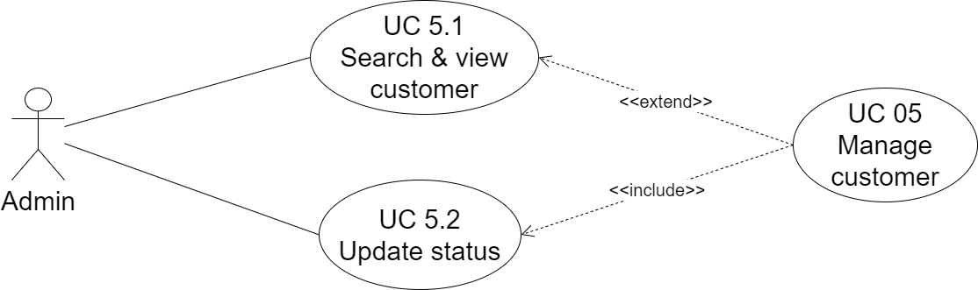

* + 1. Search & view customer

|  |  |
| --- | --- |
| Use Case Name | Search & View customer |
| Use Case ID | UC 5.1 |
| Description | Admin search and view customer information |
| Actor | Admin |
| Triggers | Admin selects "Customer Management" button |
| Preconditions | Admin login into Website from Admin |
| Postconditions | Admin can track profile members on the website |
| Main Course | 1. Display Customer Management page  2. Enter search information  3. The system checks the information entered  4. The system displays a list of suitable customers |
| Exceptions |  |

* + 1. Update status

|  |  |
| --- | --- |
| Use Case Name | Update status |
| Use Case ID | UC 5.2 |
| Description | Admin changes the active status of the members |
| Actor | Admin |
| Triggers | Admin selects “Active" button |
| Preconditions | Admin login into Website from Admin |
| Postconditions | Admin can track profile members on the website |
| Main Course | 1. The system sends a confirmation message  2. Admin confirmed  3. The system notifies the status update successfully |
| Exceptions |  |

* 1. Manage category – UC 06

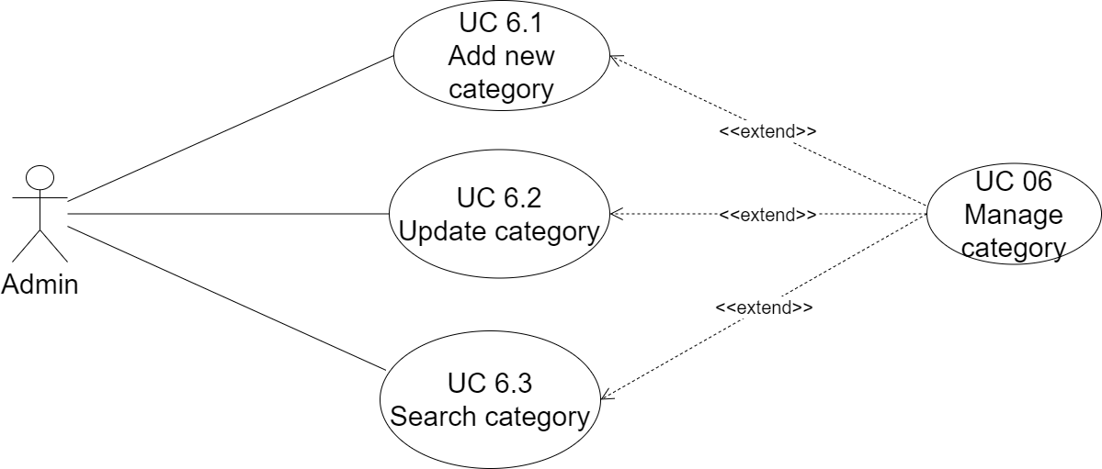

* + 1. Add new category

|  |  |
| --- | --- |
| Use Case Name | Add new category |
| Use Case ID | UC 6.1 |
| Description | Admin creates new categories for easy sorting and searching |
| Actor | Admin |
| Triggers | Admin selects "Category Management" and “New” button |
| Preconditions | Admin login into Website from Admin |
| Postconditions | Admin successfully created new categories |
| Main Course | 1. Enter new category information  2. System check and confirm information added (EX1)  3. The system will display a successful new added message and return the "Category page" |
| Exceptions | Example: Category already exists: When a category already exists in the database  1. The system displays the message 'category already exists' and displays the new add screen again  2. Go back to step 2 of Main Course |

* + 1. Update category

|  |  |
| --- | --- |
| Use Case Name | Update category |
| Use Case ID | UC 6.2 |
| Description | Help Admin change category information |
| Actor | Admin |
| Triggers | Admin click on category name |
| Preconditions | Admin login into Website from Admin |
| Postconditions | Notice of successful information update category |
| Main Course | 1. Enter the category name to edit  2. System check and confirm information  3. The system notifies you that the information has been updated successfully |
| Exceptions |  |

* + 1. Search category

|  |  |
| --- | --- |
| Use Case Name | Search category |
| Use Case ID | UC 6.3 |
| Description | Help Admin to search the category easily |
| Actor | Admin |
| Triggers | Admin enter information in the search bar |
| Preconditions | Admin login into Website from Admin |
| Postconditions | View, change information of categories |
| Main Course | 1. The system displays a list of suitable categories |
| Exceptions |  |

* 1. Manage product – UC 07

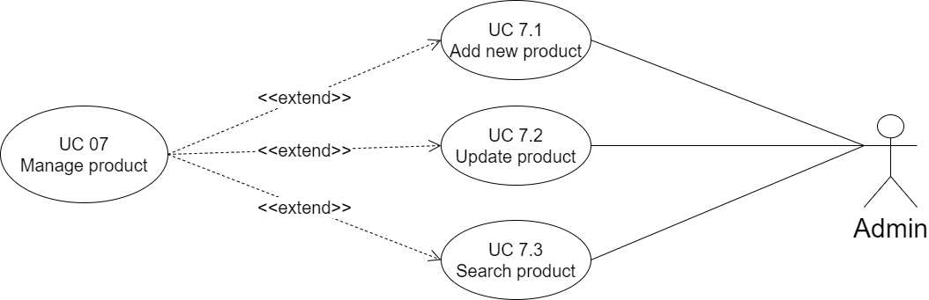

* + 1. Add new product

|  |  |
| --- | --- |
| Use Case Name | Add new product |
| Use Case ID | UC 7.1 |
| Description | Admin creates new products for easy sorting and searching |
| Actor | Admin |
| Triggers | Admin selects "Product Management" and “New” button |
| Preconditions | Admin login into Website from Admin |
| Postconditions | Admin successfully created new products |
| Main Course | 1. Enter new products information  2. System check and confirm information added (EX1)  3. The system will display a successful new added message and return the "Product page" |
| Exceptions | Example: Product already exists: When a product already exists in the database  1. The system displays the message ‘product already exists' and displays the new add screen again  2. Go back to step 2 of Main Course |

* + 1. Update product

|  |  |
| --- | --- |
| Use Case Name | Update product |
| Use Case ID | UC 7.2 |
| Description | Help Admin change product information |
| Actor | Admin |
| Triggers | Admin click on product name |
| Preconditions | Admin login into Website from Admin |
| Postconditions | Notice of successful information update product |
| Main Course | 1. Enter the product name to edit  2. System check and confirm information  3. The system notifies you that the information has been updated successfully |
| Exceptions |  |

* + 1. Search product

|  |  |
| --- | --- |
| Use Case Name | Search product |
| Use Case ID | UC 7.3 |
| Description | Help Admin to search the product easily |
| Actor | Admin |
| Triggers | Admin enter information in the search bar |
| Preconditions | Admin login into Website from Admin |
| Postconditions | View, change information of products |
| Main Course | 1. Enter product name  2. The system displays a list of suitable products |
| Exceptions |  |

* 1. Manage brand – UC 08

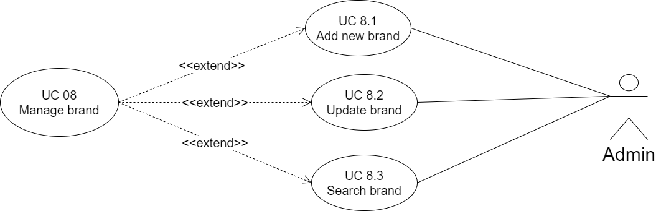

* + 1. Add new brand

|  |  |
| --- | --- |
| Use Case Name | Add new brand |
| Use Case ID | UC 8.1 |
| Description | Admin creates new brands for easy sorting and searching |
| Actor | Admin |
| Triggers | Admin selects "Brand Management" and “New” button |
| Preconditions | Admin login into Website from Admin |
| Postconditions | Admin successfully created new brands |
| Main Course | 1. Enter new brand information  2. System check and confirm information added (EX1)  3. The system will display a successful new added message and return the "Brand Management page" |
| Exceptions | Example: Brand already exists: When a brand already exists in the database  1. The system displays the message ‘brand already exists' and displays the new add screen again  2. Go back to step 2 of Main Course |

* + 1. Update brand

|  |  |
| --- | --- |
| Use Case Name | Update brand |
| Use Case ID | UC 8.2 |
| Description | Help Admin change brand information |
| Actor | Admin |
| Triggers | Admin click on brand name |
| Preconditions | Admin login into Website from Admin |
| Postconditions | Notice of successful information update brand |
| Main Course | 1. Enter the product brand to edit  2. System check and confirm information  3. The system notifies you that the information has been updated successfully |
| Exceptions |  |

* + 1. Search brand

|  |  |
| --- | --- |
| Use Case Name | Search product |
| Use Case ID | UC 8.3 |
| Description | Help Admin to search the brand easily |
| Actor | Admin |
| Triggers | Admin enter information in the search bar |
| Preconditions | Admin login into Website from Admin |
| Postconditions | View, change information of brands |
| Main Course | 1. Enter search information  2. The system displays a list of suitable brands |
| Exceptions |  |

* 1. Manage size – UC 09

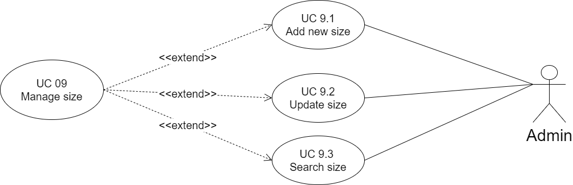

* + 1. Add new size

|  |  |
| --- | --- |
| Use Case Name | Add new size |
| Use Case ID | UC 9.1 |
| Description | Admin creates new sizes for easy sorting and searching |
| Actor | Admin |
| Triggers | Admin selects "Size Management" and “New” button |
| Preconditions | Admin login into Website from Admin |
| Postconditions | Admin successfully created new sizes |
| Main Course | 1. Enter new size  2. System check and confirm information added (EX1)  3. The system will display a successful new added message and return the Size Management page |
| Exceptions | Example: Size already exists: When a size already exists in the database  1. The system displays the message 'size already exists' and displays the new add screen again  2. Go back to step 2 of Main Course |

* + 1. Update size

|  |  |
| --- | --- |
| Use Case Name | Update size |
| Use Case ID | UC 9.2 |
| Description | Help Admin change size information |
| Actor | Admin |
| Triggers | Admin click on size name |
| Preconditions | Admin login into Website from Admin |
| Postconditions | Notice of successful information update size |
| Main Course | 1. Enter the size to edit  2. System check and confirm information  3. The system notifies you that the information has been updated successfully |
| Exceptions |  |

* + 1. Search size

|  |  |
| --- | --- |
| Use Case Name | Search size |
| Use Case ID | UC 9.3 |
| Description | Help Admin to search the size easily |
| Actor | Admin |
| Triggers | Admin enter the required size in the search bar |
| Preconditions | Admin login into Website from Admin |
| Postconditions | View, change the active state of the size |
| Main Course | 1. Enter search information  2. The system displays a list of suitable sizes |
| Exceptions |  |

* 1. Manage coupons – UC 10

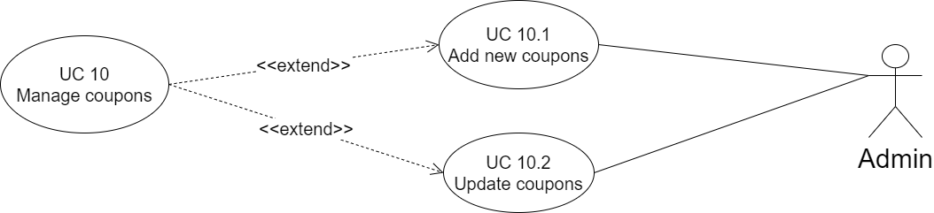

* + 1. Add new coupons

|  |  |
| --- | --- |
| Use Case Name | Add new coupons |
| Use Case ID | UC 10.1 |
| Description | Admin creates new coupons for easy sorting and searching |
| Actor | Admin |
| Triggers | Admin selects "Coupons Management" and “New” button |
| Preconditions | Admin login into Website from Admin |
| Postconditions | Admin successfully created new coupons |
| Main Course | 1. Enter new coupons  2. System check and confirm information added (EX1)  3. The system will display a successful new added message and return the Size Management page |
| Exceptions | Example: Coupons already exists: When a size already exists in the database  1. The system displays the message 'coupons already exists' and displays the new add screen again  2. Go back to step 2 of Main Course |

* + 1. Update coupons

|  |  |
| --- | --- |
| Use Case Name | Update coupons |
| Use Case ID | UC 10.2 |
| Description | Help Admin change coupons |
| Actor | Admin |
| Triggers | Admin click on coupons name |
| Preconditions | Admin login into Website from Admin |
| Postconditions | Notice of successful information update coupons |
| Main Course | 1. Enter the coupons to edit  2. System check and confirm information  3. The system notifies you that the information has been updated successfully |
| Exceptions |  |

* 1. Manage website – UC 11

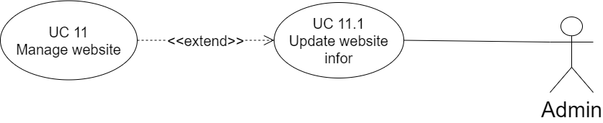

* + 1. Update website information

|  |  |
| --- | --- |
| Use Case Name | Update website information |
| Use Case ID | UC 11.1 |
| Description | Help Admin change website information |
| Actor | Admin |
| Triggers | Admin selects the item to update |
| Preconditions | Admin login into Website from Admin |
| Postconditions | Display a message of successful change of contact information |
| Main Course | 1. Enter the content to update  2. Admin confirmed the change  3. The system confirms the change and reloads the page |
| Exceptions |  |

1. Activity Diagram

* Customer
  1. Register UC

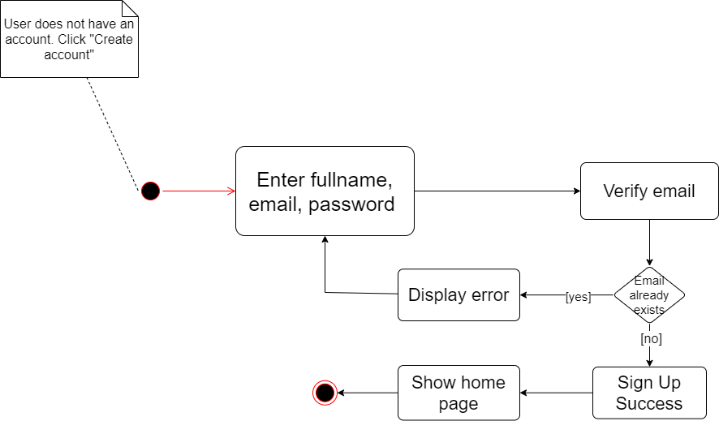

* 1. Login

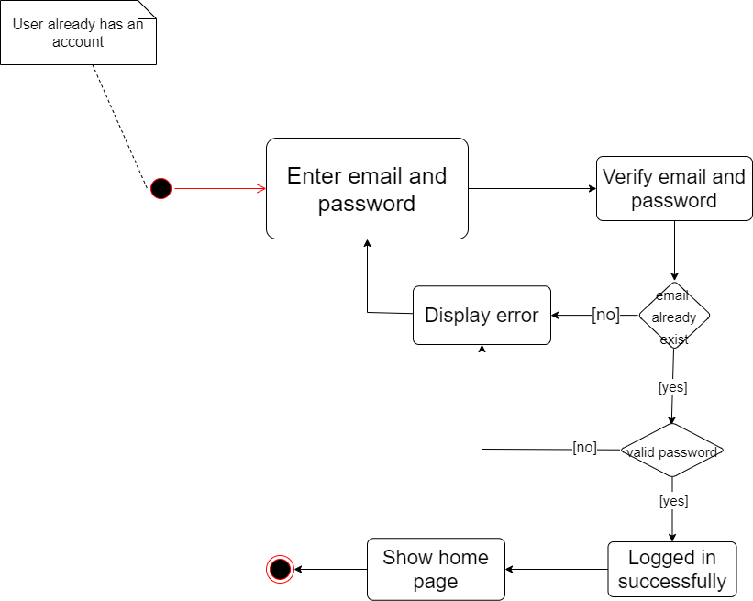

* 1. Update profile

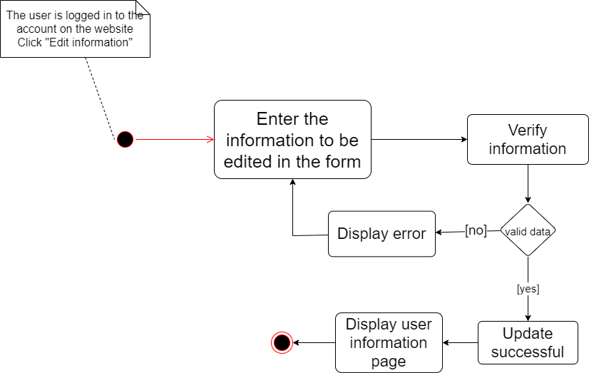

* 1. Change password

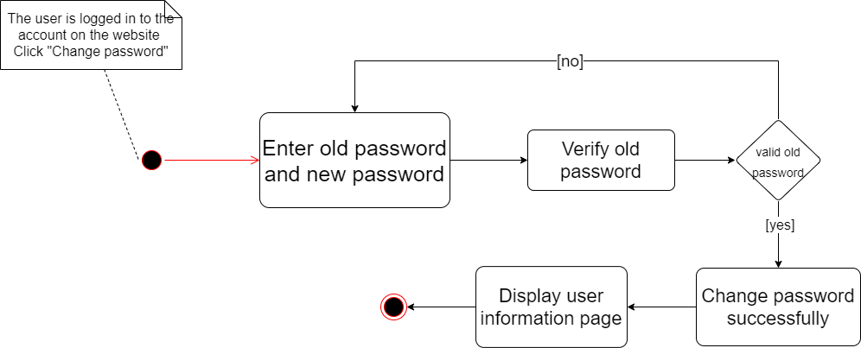

* 1. Search product

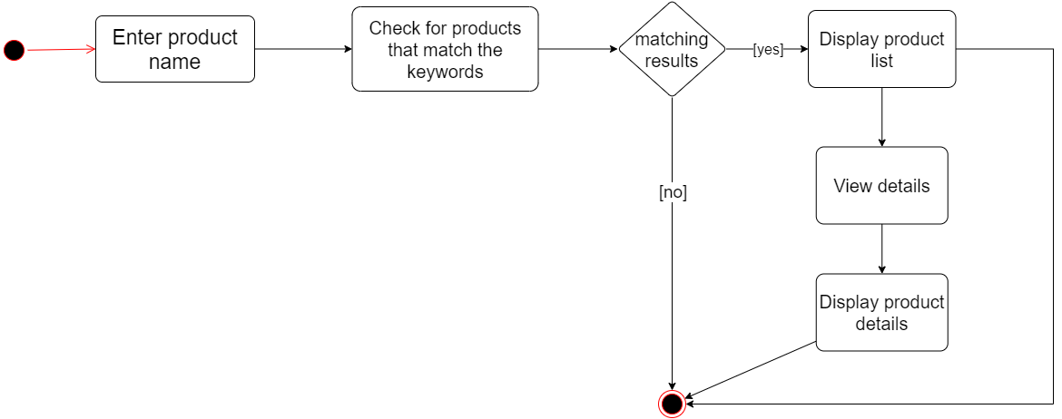

* 1. Add to cart

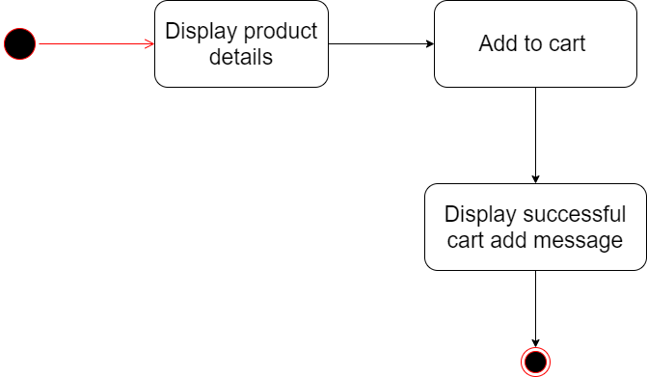

* 1. Order

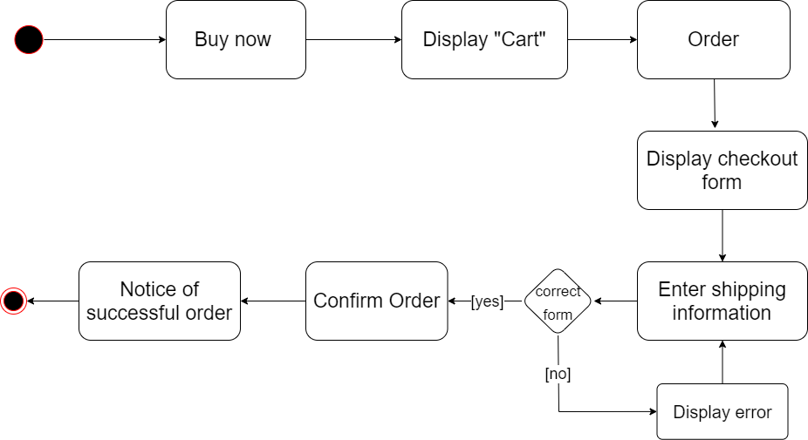

* 1. View order history

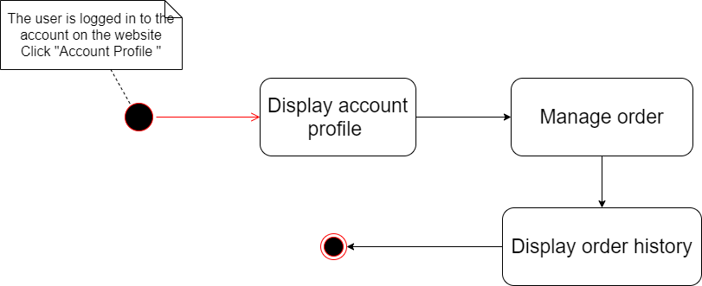

* 1. Cancel order

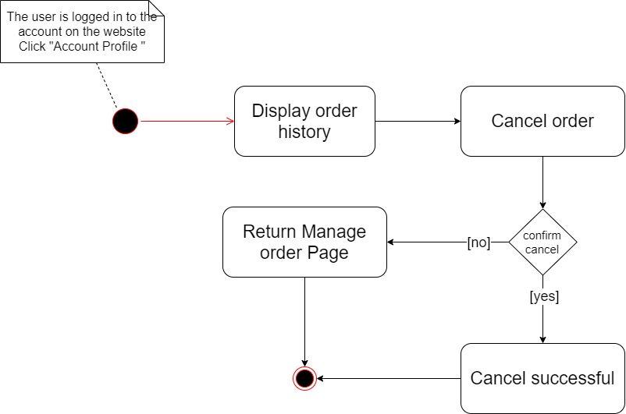

* 1. Search & view customer

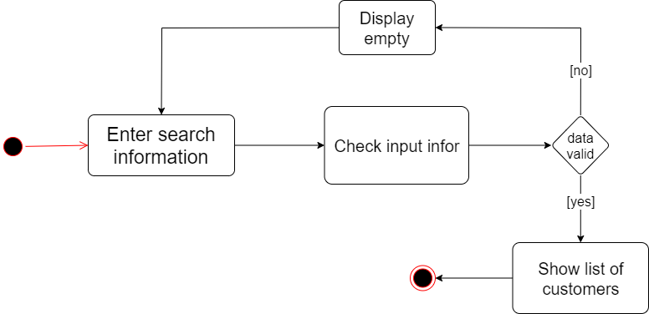

* 1. Update status

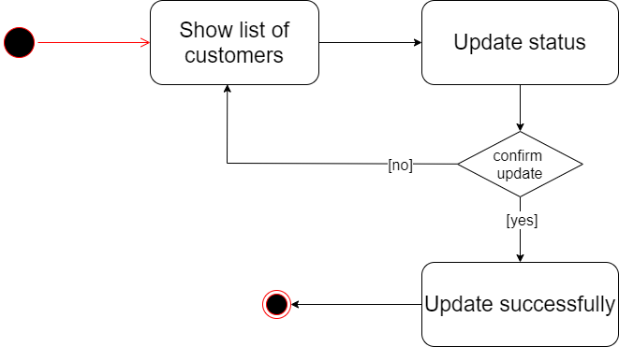

* 1. Add new category

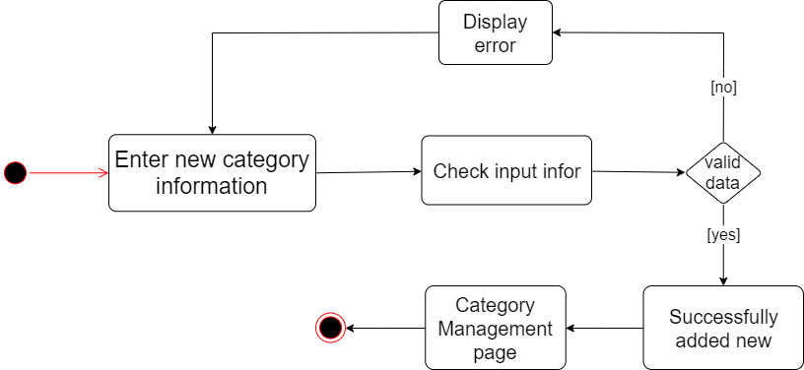

* 1. Update category

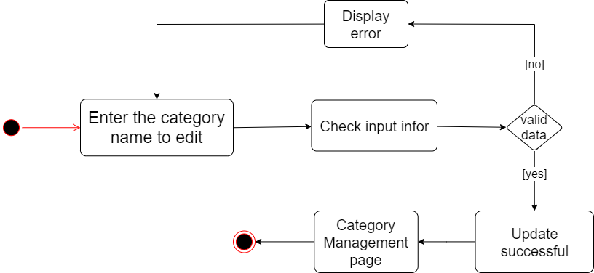

* 1. Search category

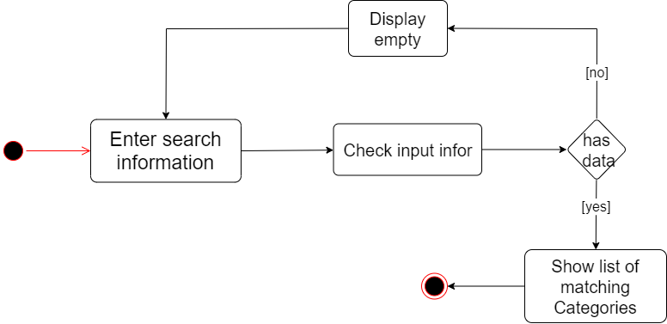

* 1. Add new product

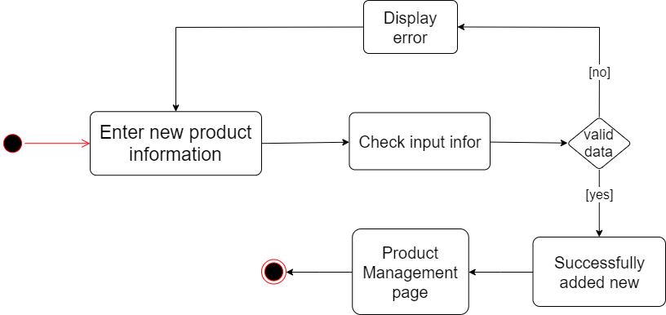

* 1. Update product

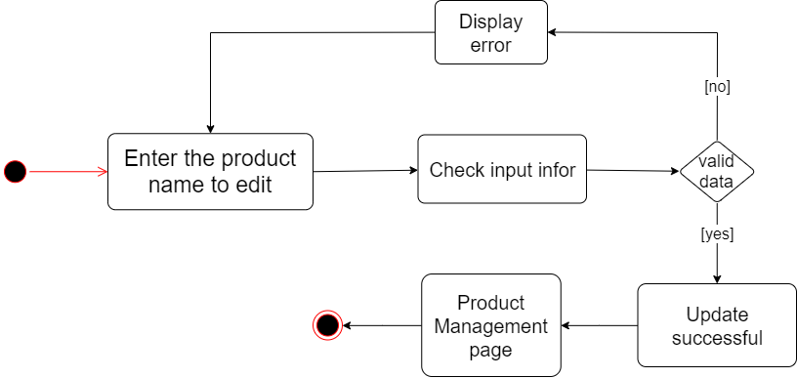

* 1. Search product

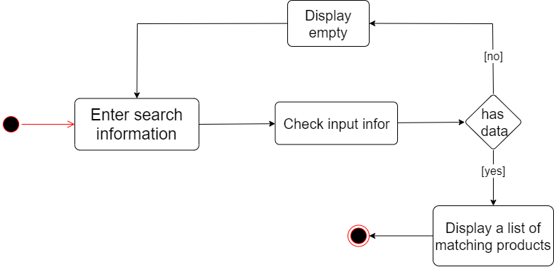

* 1. Add new brand

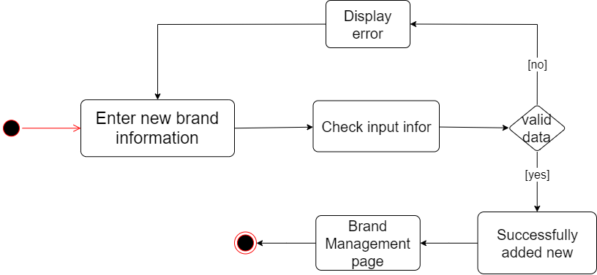

* 1. Update brand

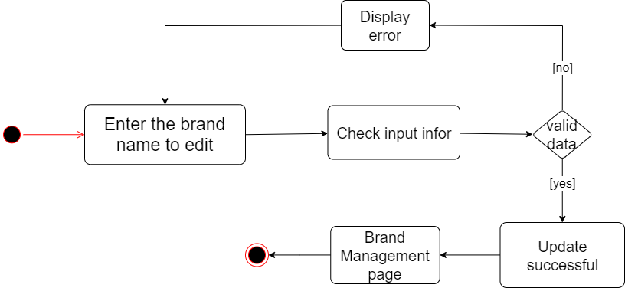

* 1. Search brand

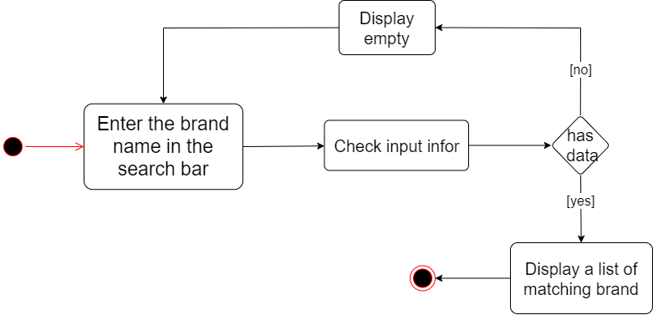

* 1. Add new size

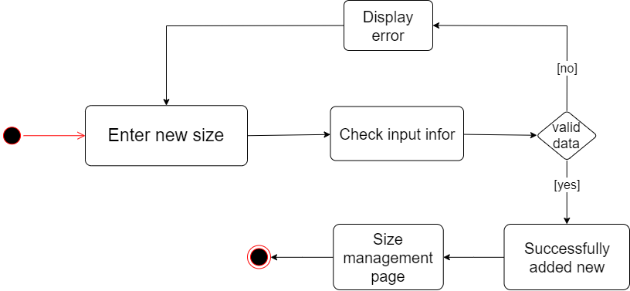

* 1. Update size

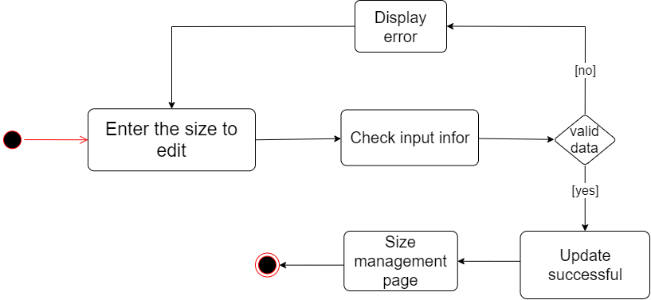

* 1. Search size

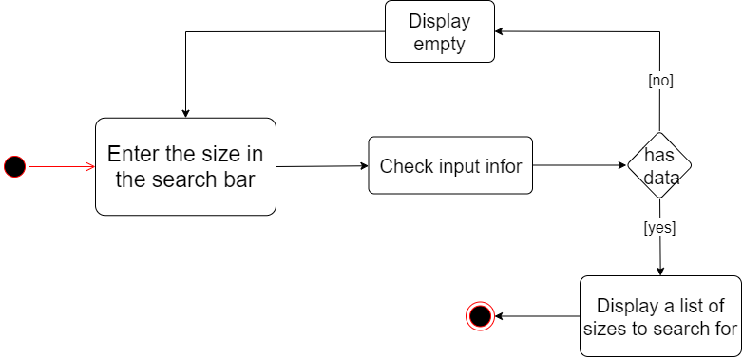

* 1. Add new coupon

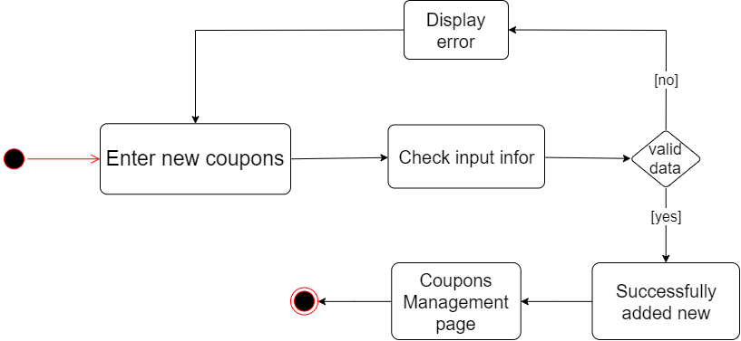

* 1. Update coupon

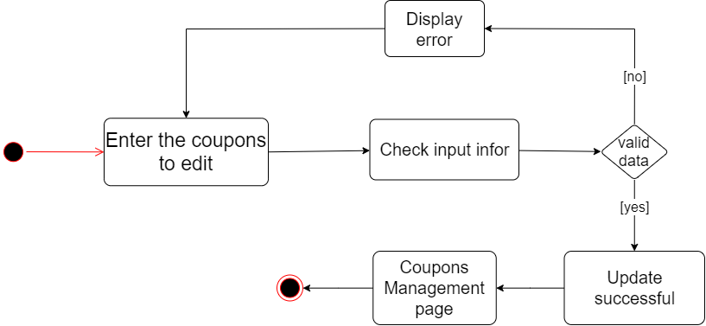

* 1. Update website information

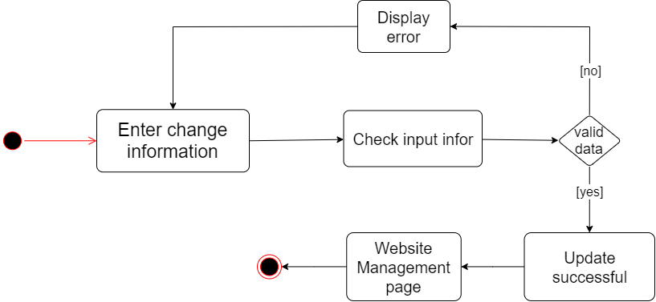

1. **Desgin details**
2. 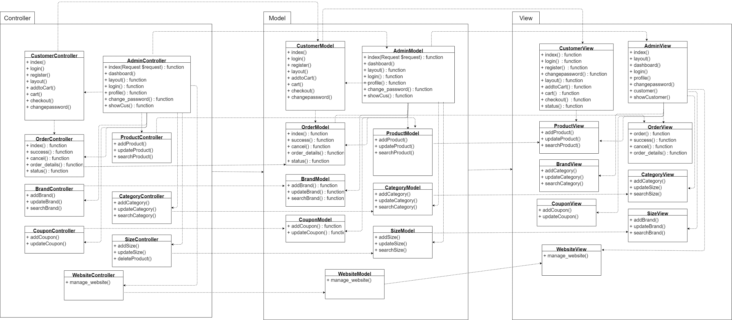Class Diagram
3. Sequence Diagram

* Register

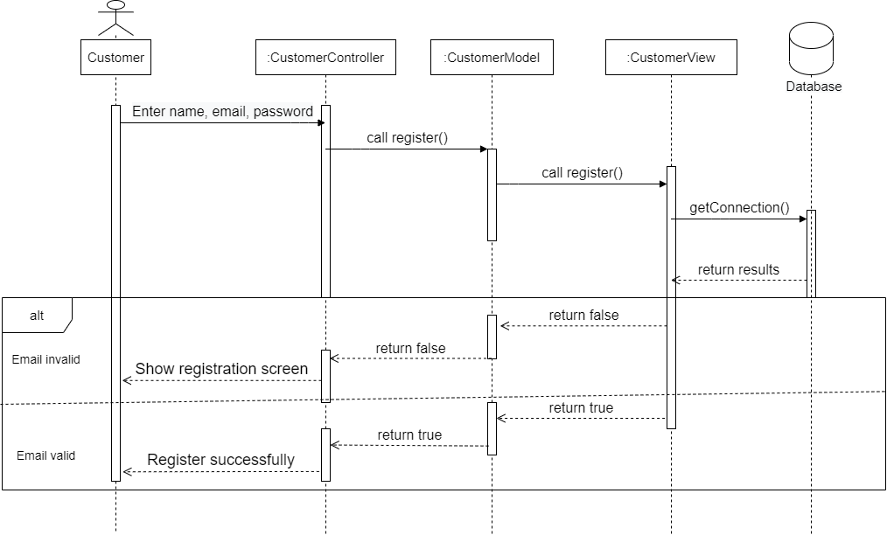

* Login

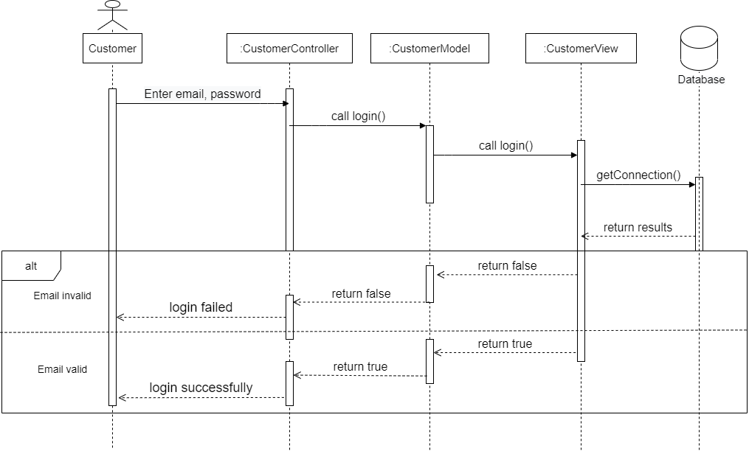

* Update profile

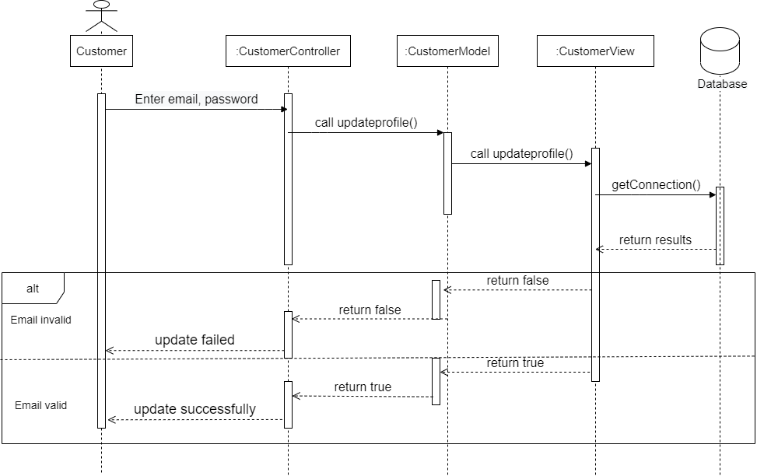

* Change password

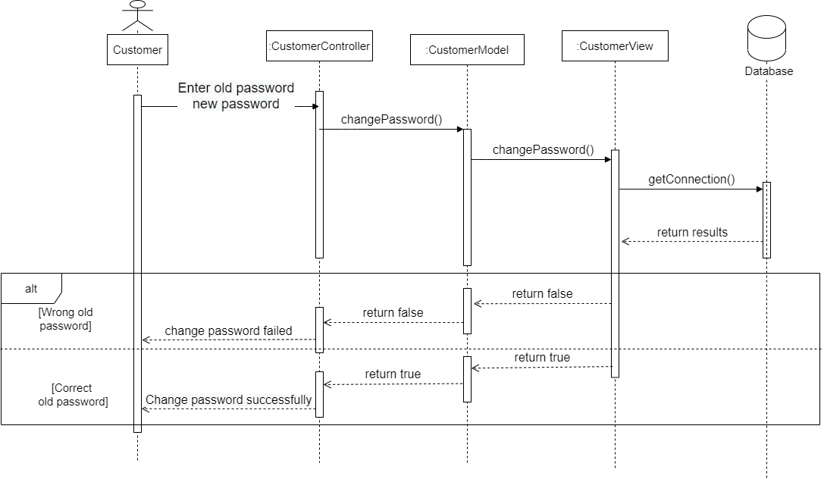

* Search product

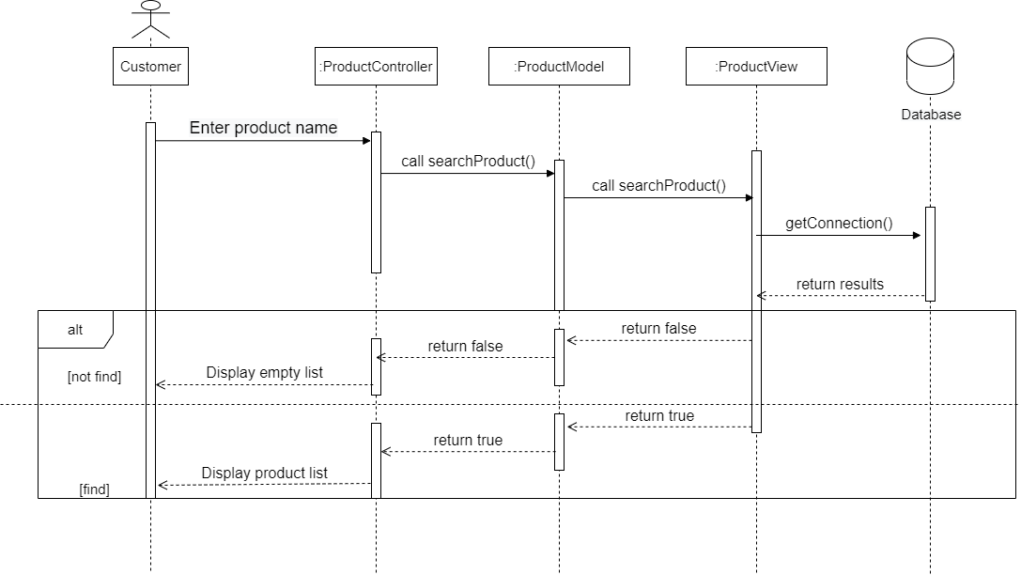

* View product details

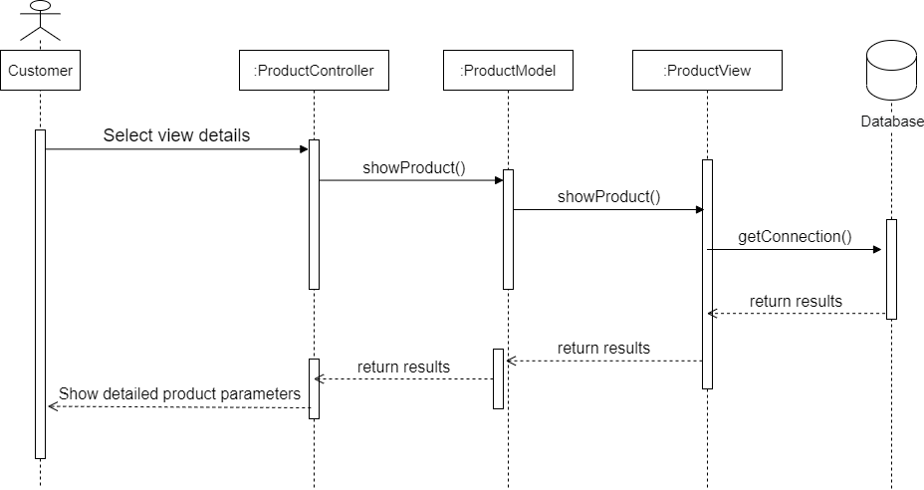

* Add to cart

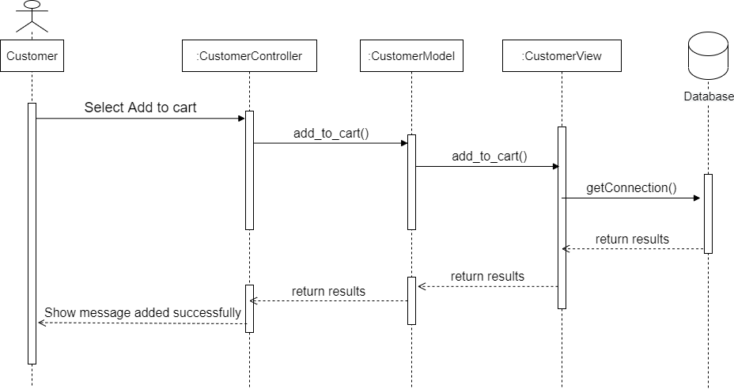

* Order

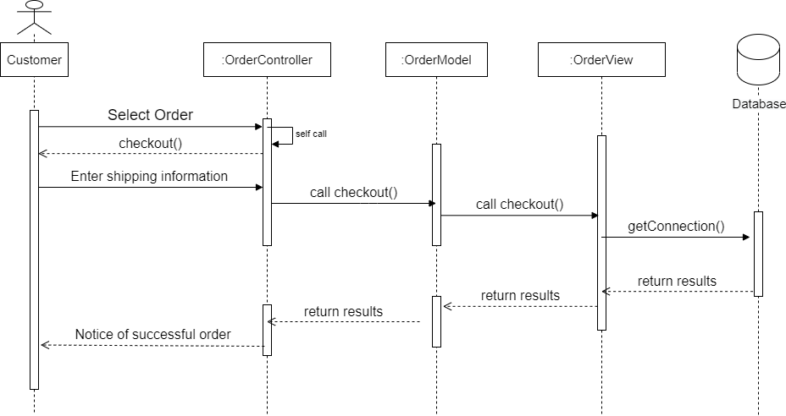

* View order history

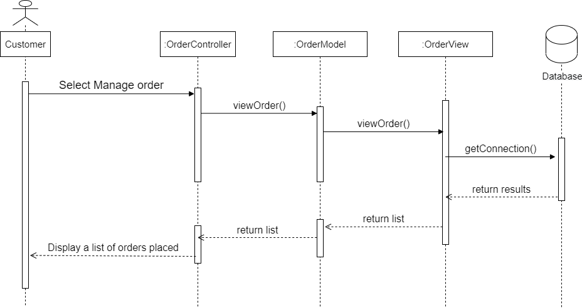

* Cancel order

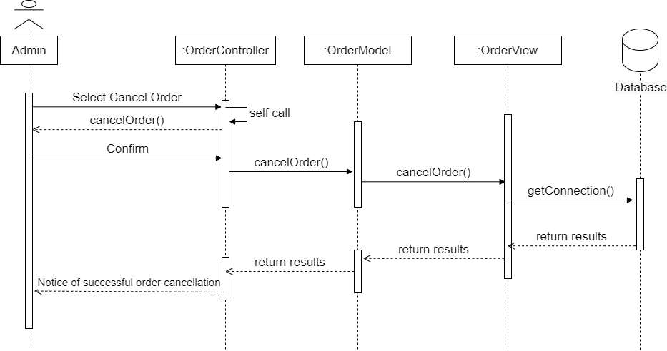

* Add new category

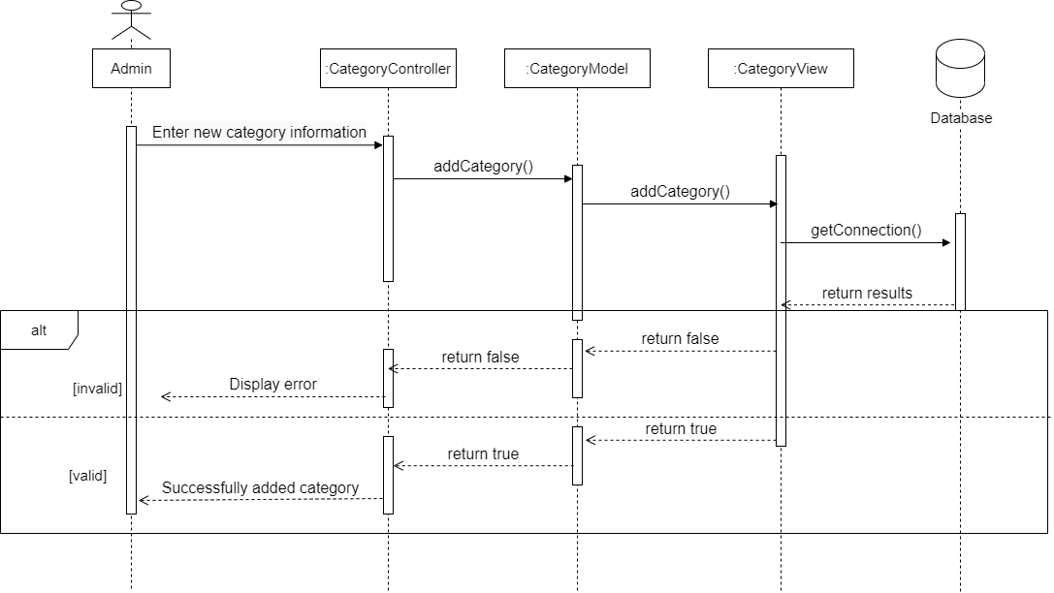

* Update category

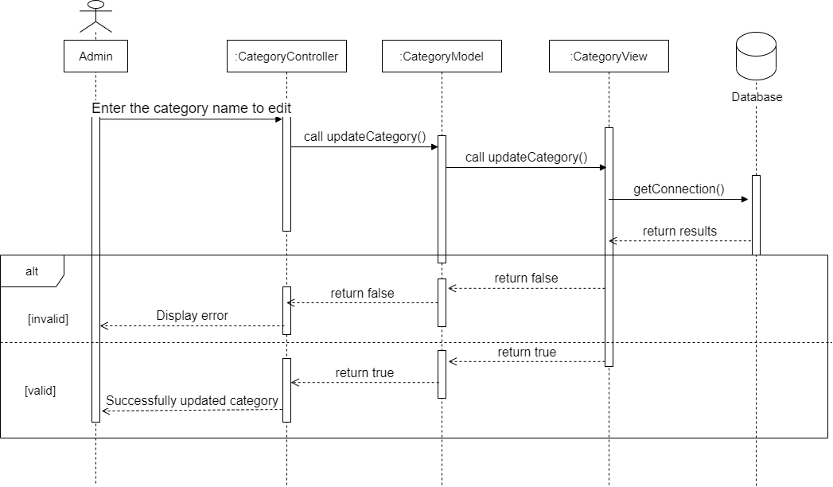

* Search category

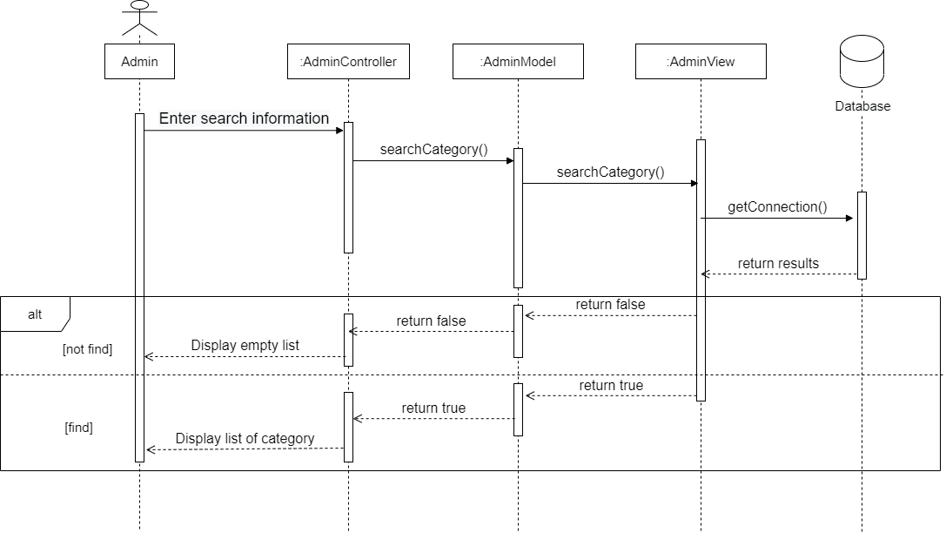

* Add new product

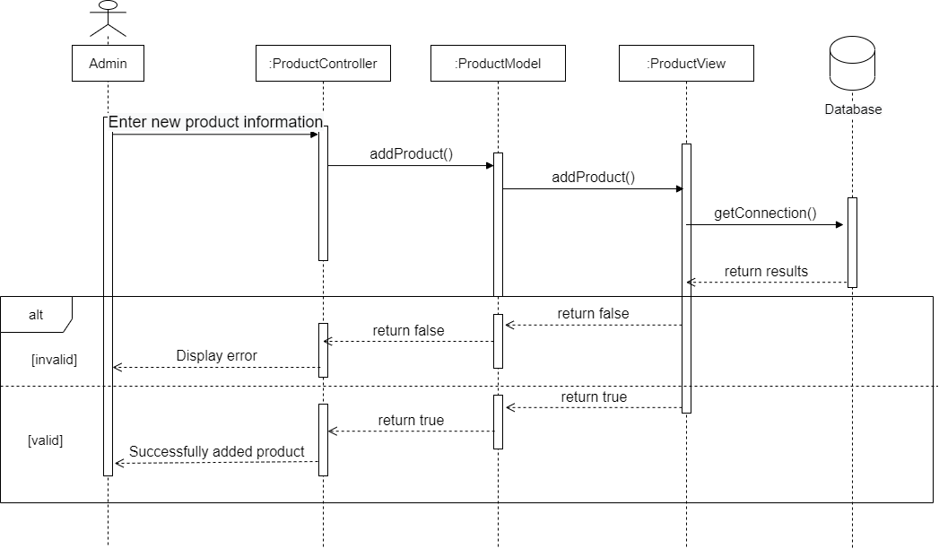

* Update product

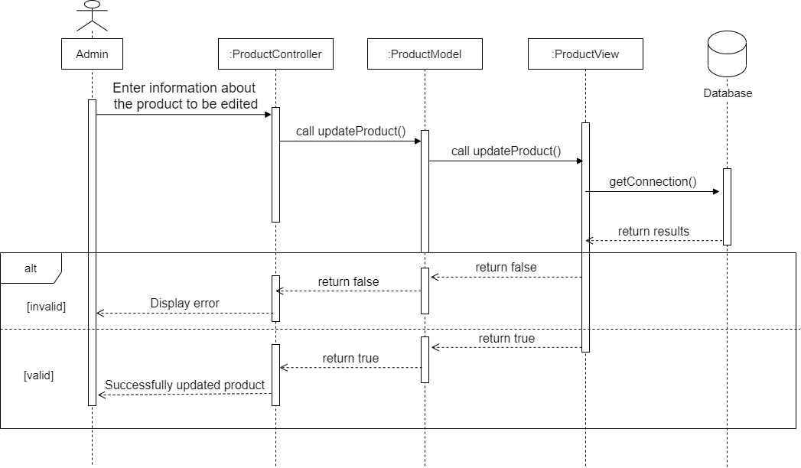

* Search product

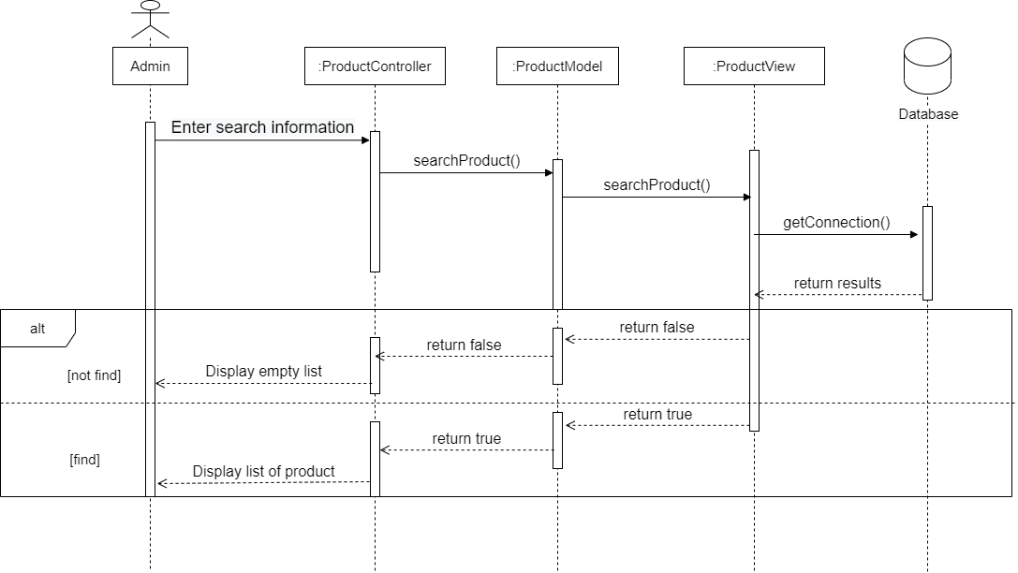

* Add new brand

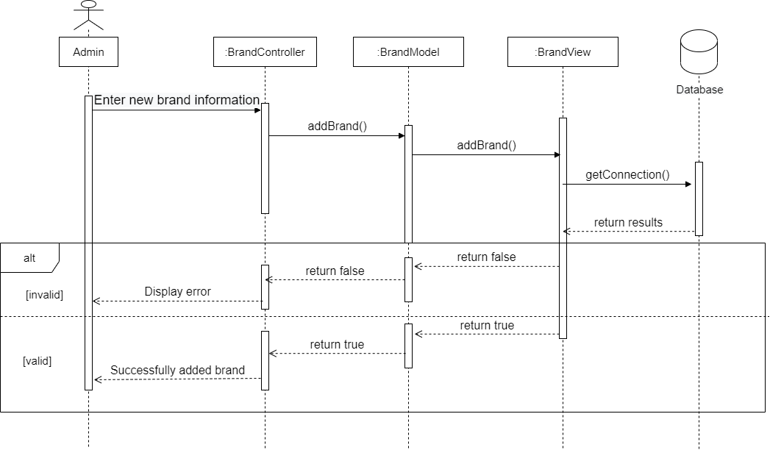

* Update brand

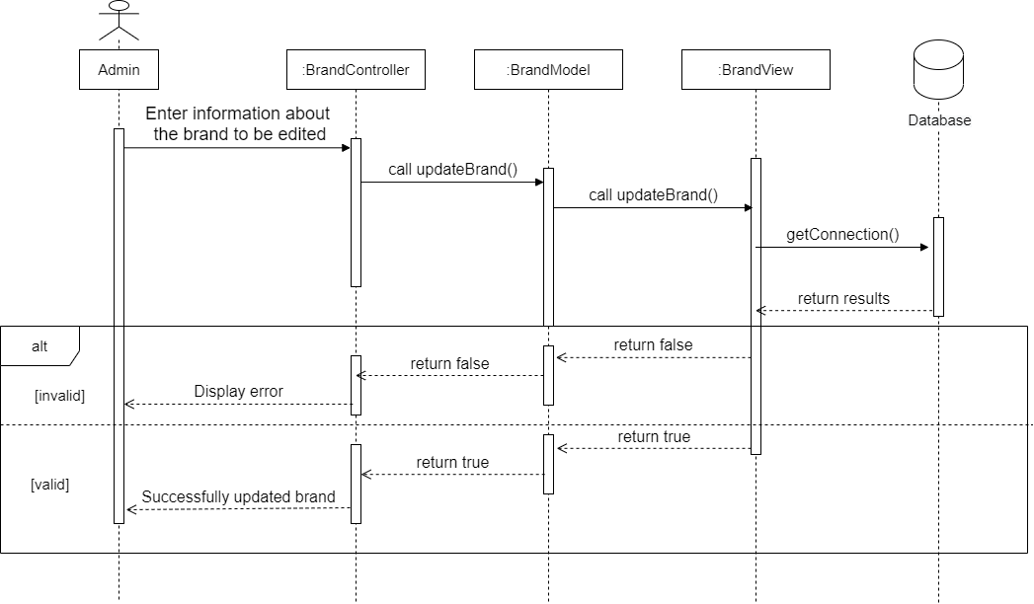

* Search brand

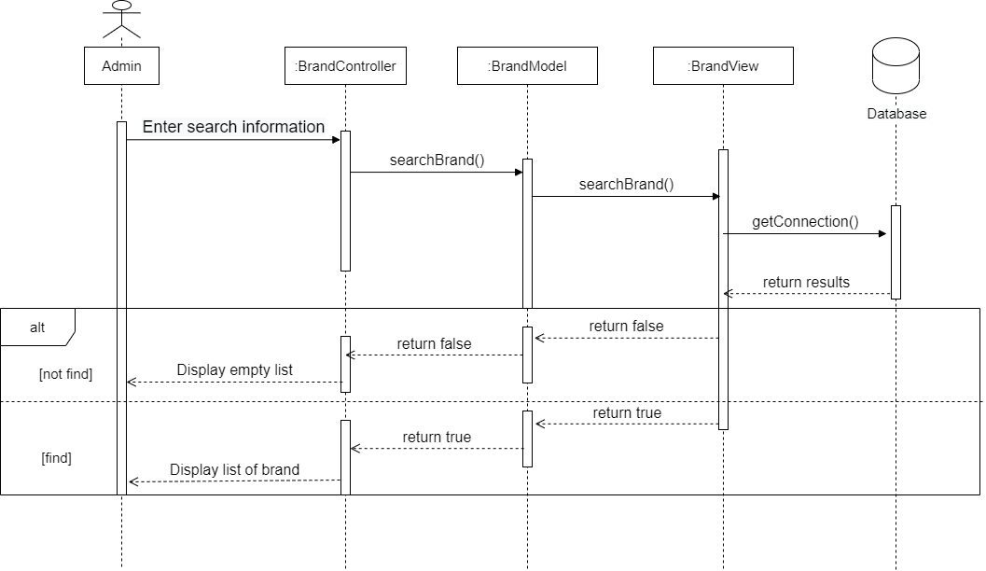

* Add new size

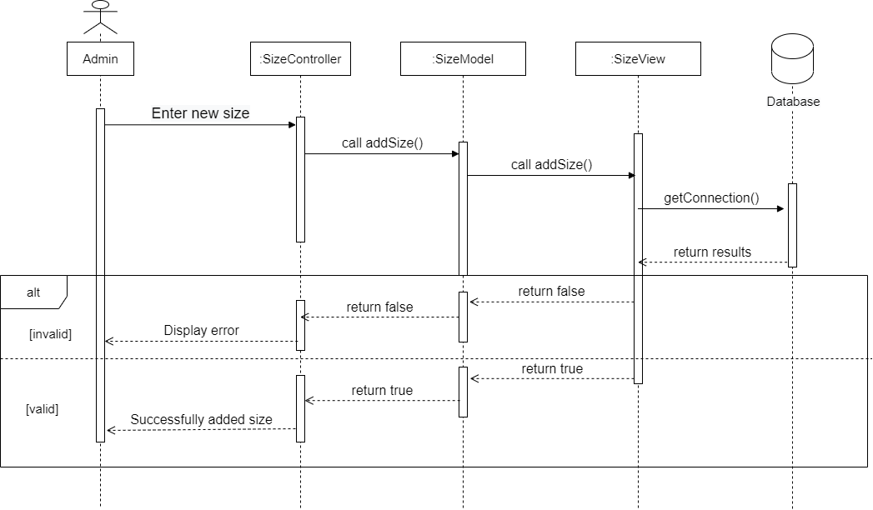

* Update size

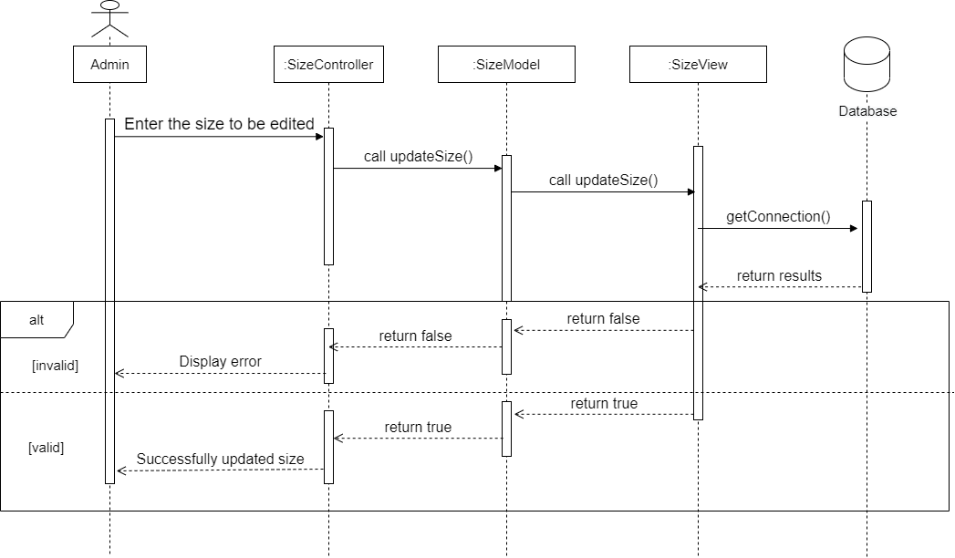

* Search size

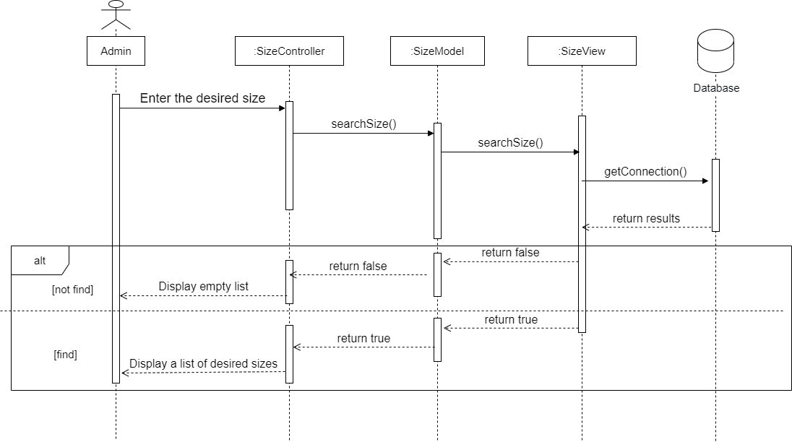

* Add new coupons

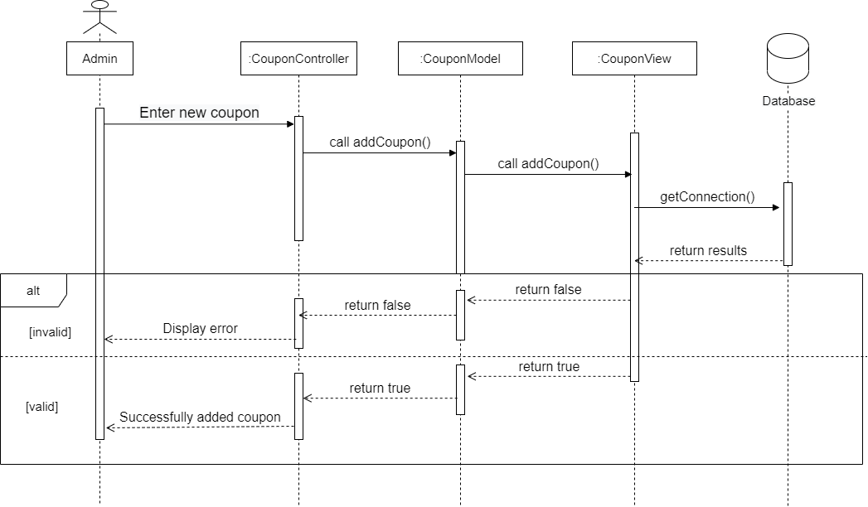

* Update coupons

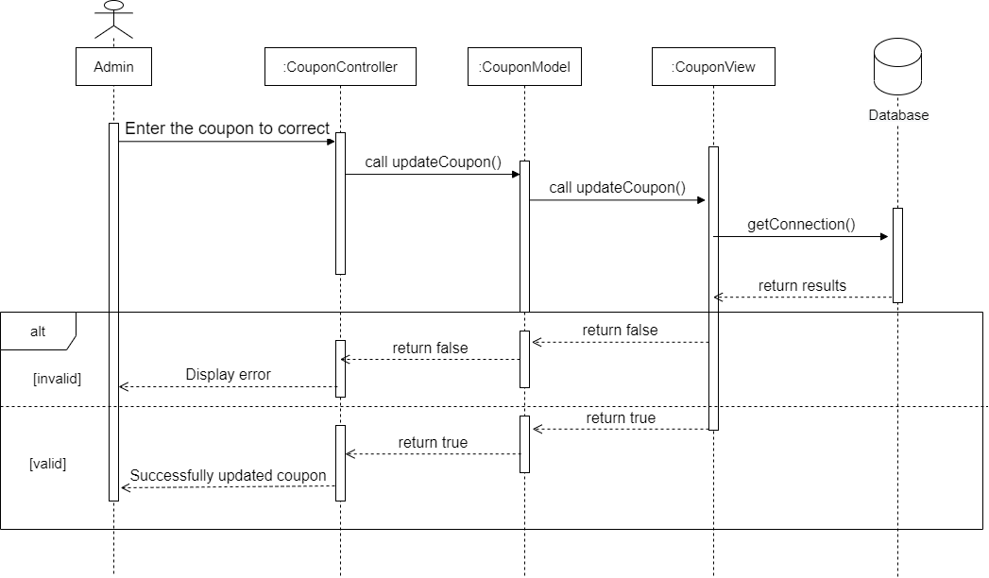

* Update website infor

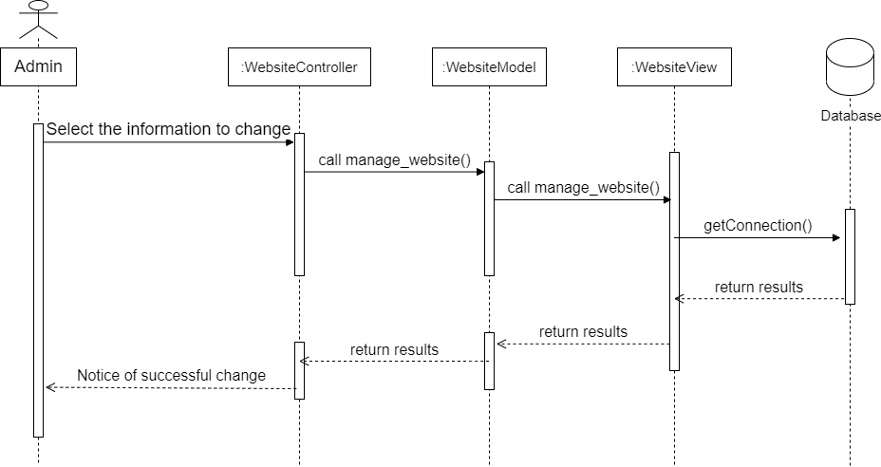

1. Database Design
   1. Entity Relationship Diagram

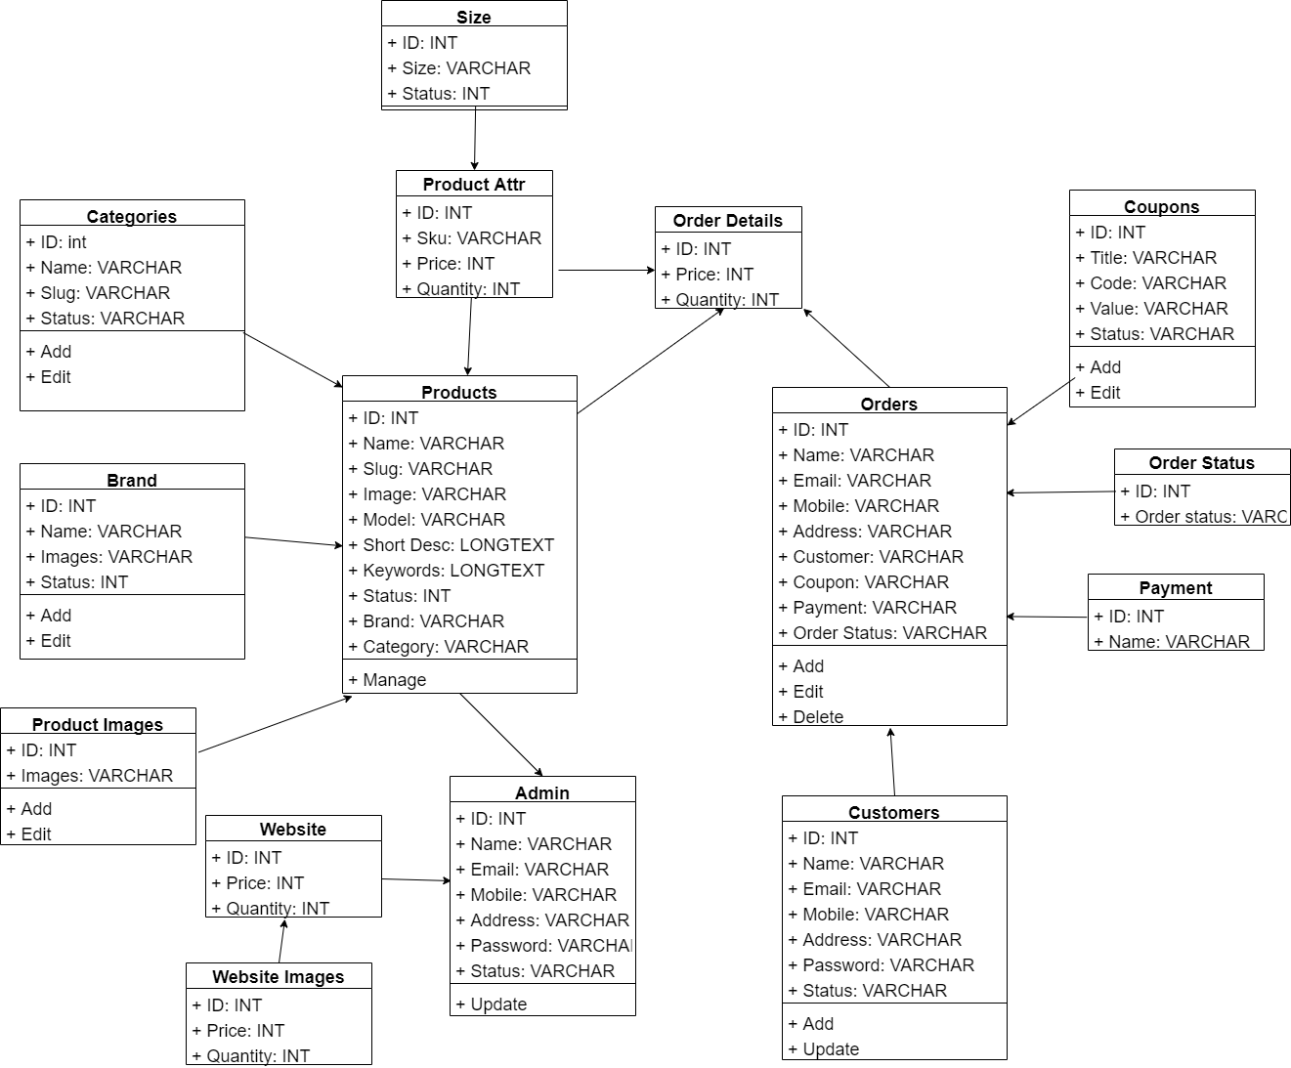

* 1. Database Design Details

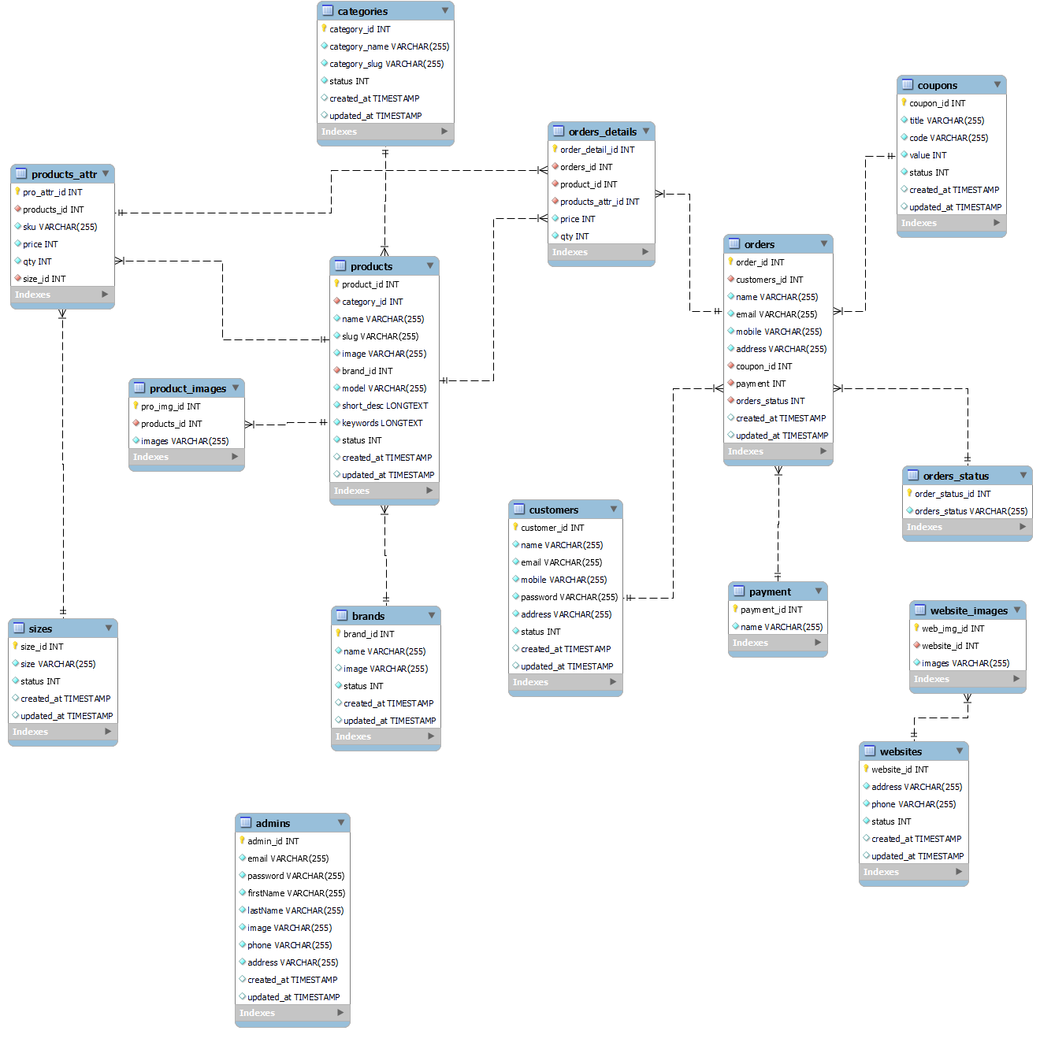

1. UI Design

**UI Home page**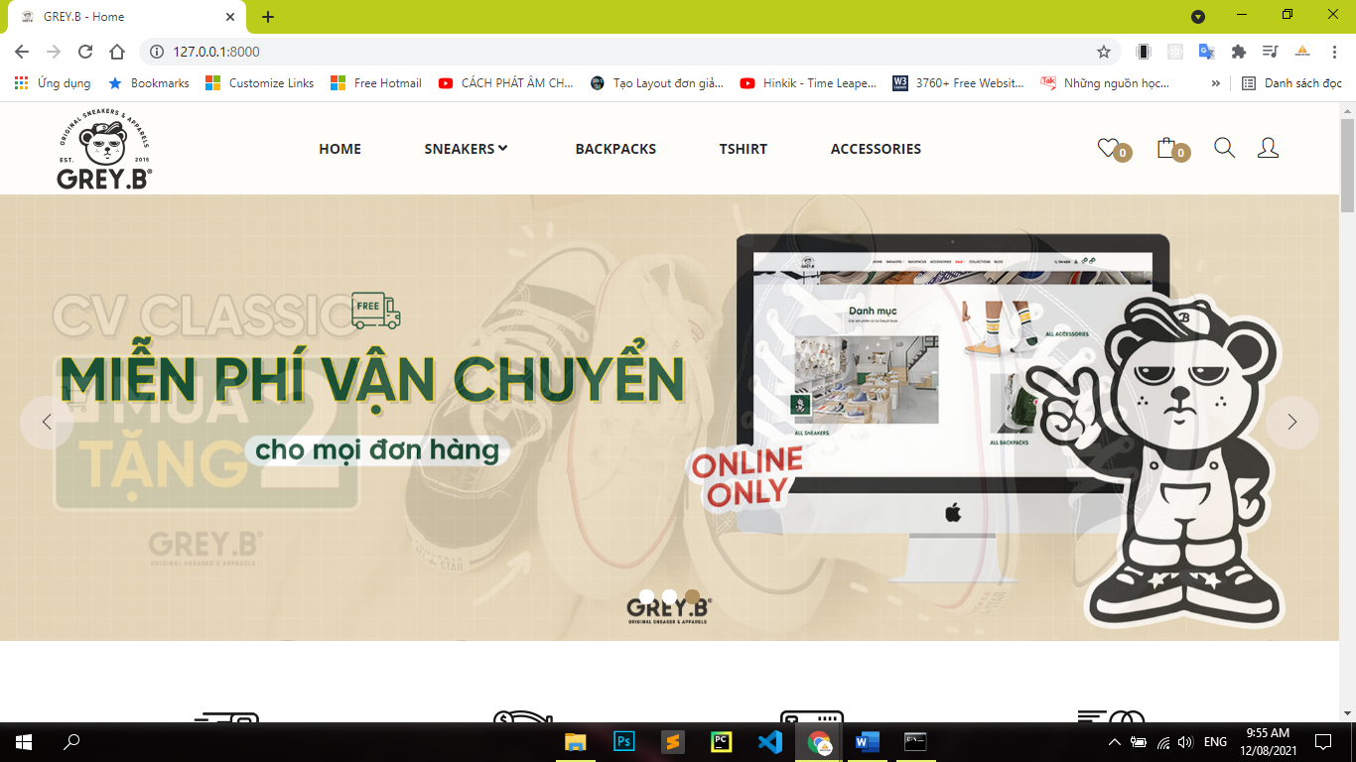

**UI Product**

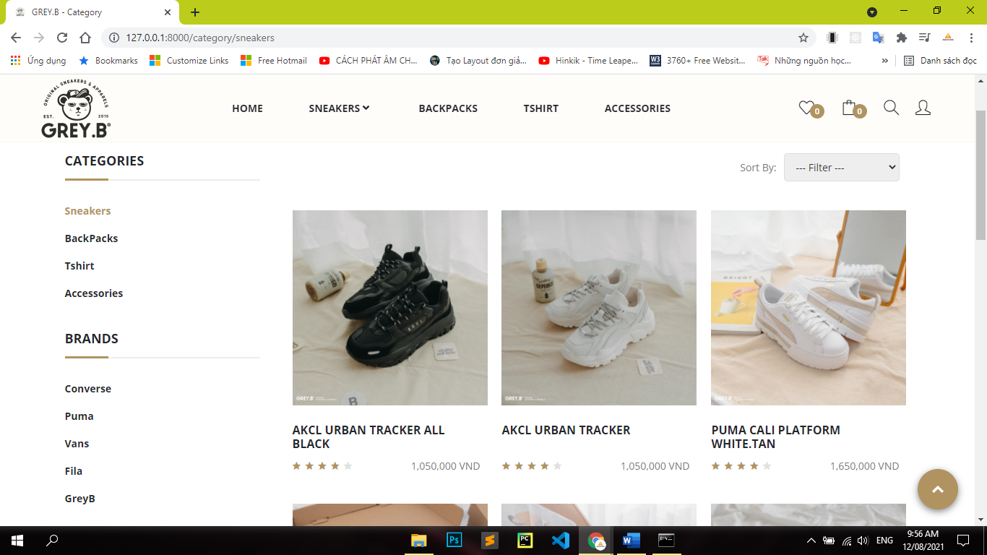

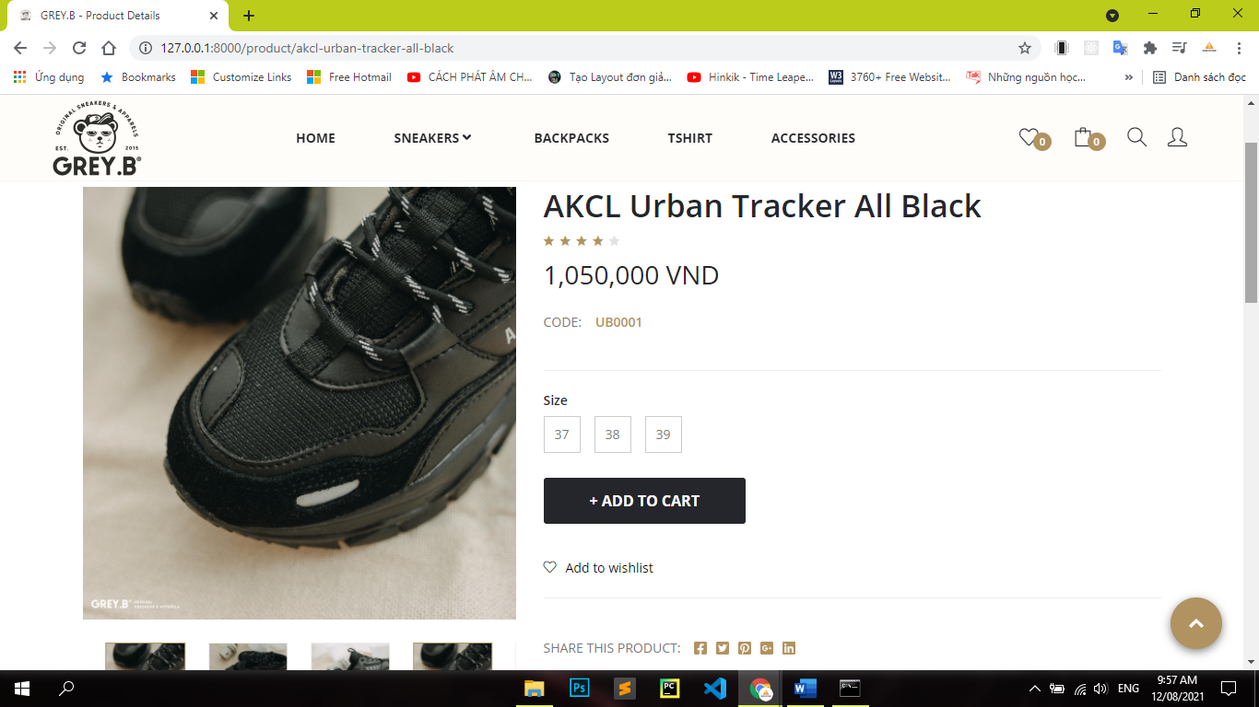

**UI Login**

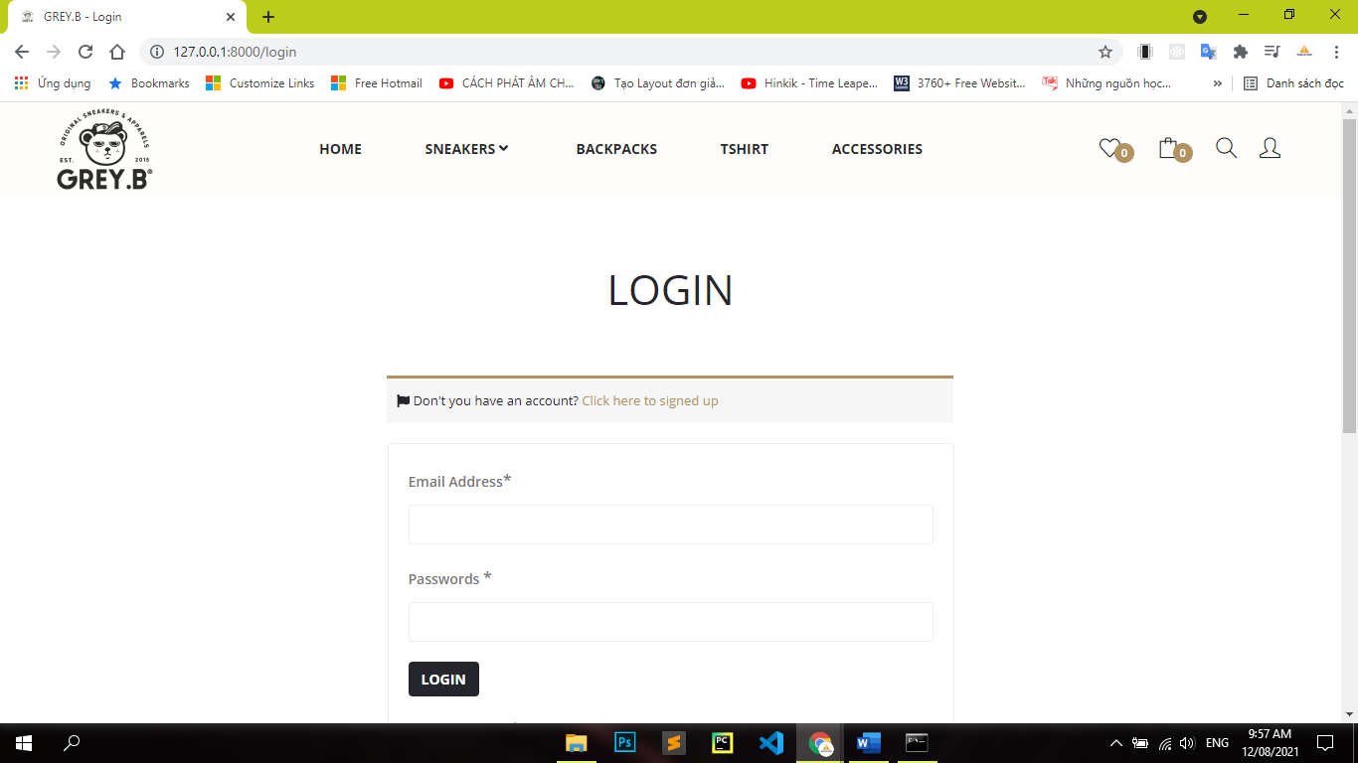

**UI Cart**

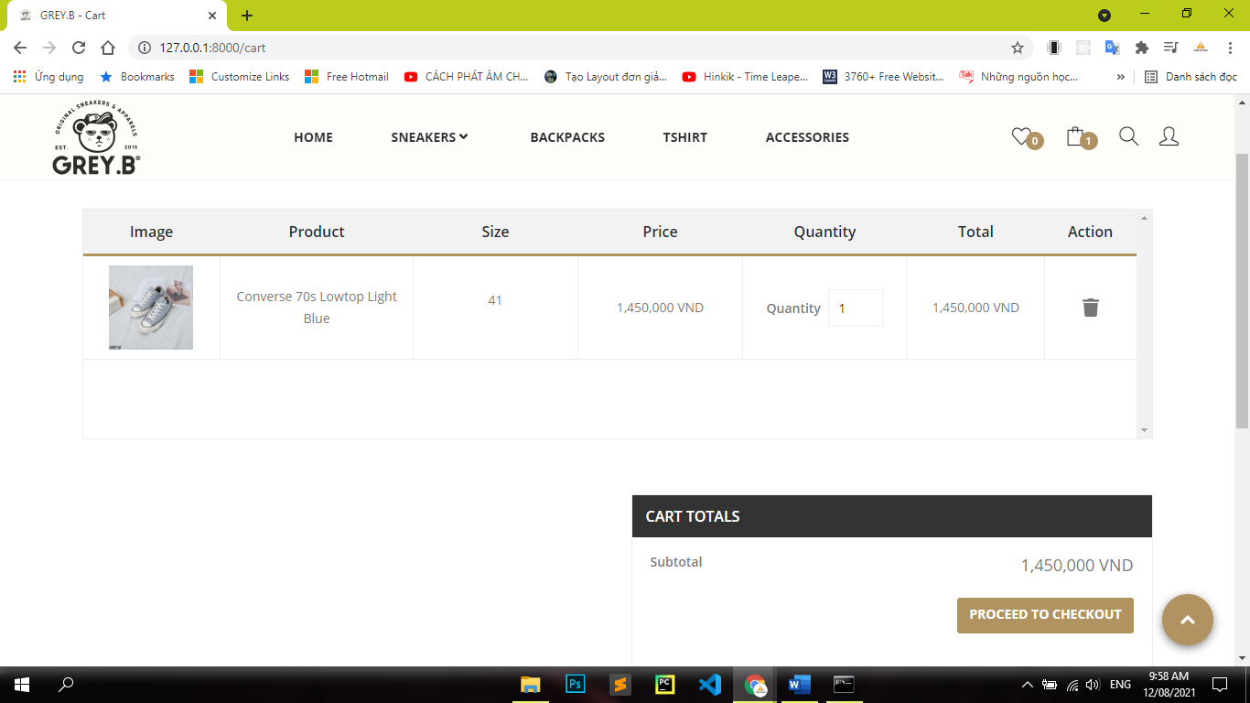

**UI Checkout**

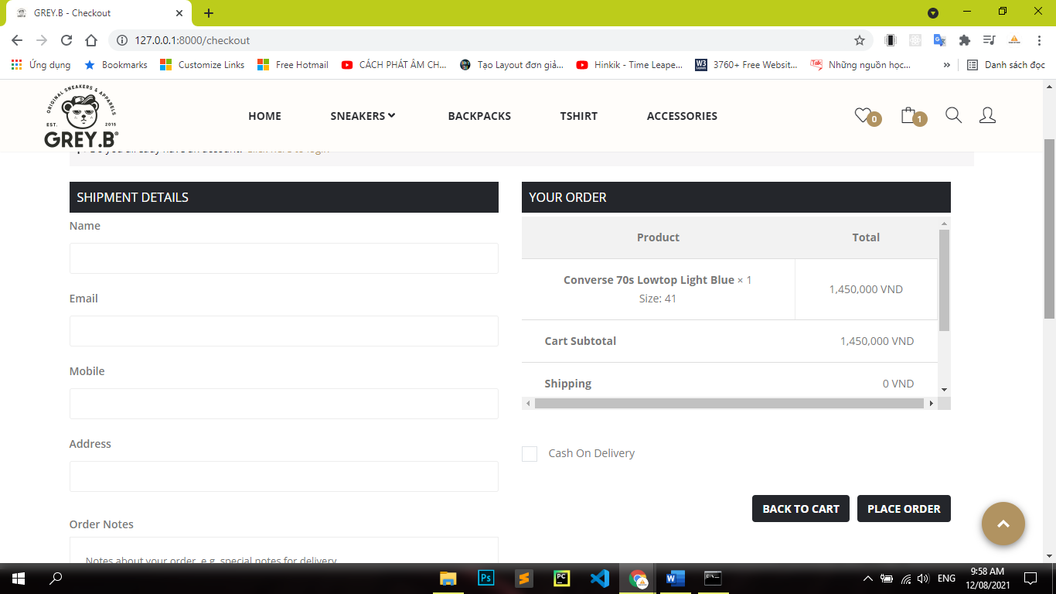

# Assign work to each team member

|  |  |  |  |  |  |  |
| --- | --- | --- | --- | --- | --- | --- |
| Group Name | Flight Ticket Management System | | | | | |
| No | Task name | Description | Start Date | End Date | Member | Self assessment |
| 1 | Admin journey | Admin journey | 15/03/2021 | 21/03/2021 | Thong | Pass |
| 2 | Customer User journey | Customer User journey | 15/03/2021 | 21/03/2021 | Son | Pass |
| 3 | Write List all Use Cases | Write List all Use Cases | 15/03/2021 | 21/03/2021 | Thanh | Pass |
| 4 | Choose subject | Discuss and choose subject | 15/03/2021 | 21/03/2021 | Thanh  Thong  Son | Pass |
| 5 | Write use case details for Admin | Write use case details for Admin | 22/03/2021 | 28/03/2021 | Thanh | Pass |
| 6 | Draw UI/UX design for Admin Control Panel | Draw UI/UX design for Admin Control Panel | 22/03/2021 | 28/03/2021 | Thanh | Pass |
| 7 | Write use case details for Customer | Write use case details for Customer | 22/03/2021 | 28/03/2021 | Thong  Son | Pass |
| 8 | Draw all use Activity Diagrams | Draw all use Activity Diagrams | 05/04/2021 | 11/04/2021 | Thong  Son | Pass |
| 9 | Draw Sequence Diagrams | Draw Sequence Diagrams | 05/04/2021 | 11/04/2021 | Thong | Pass |
| 10 | Create Shop Templates | Create Shop Templates | 05/04/2021 | 11/04/2021 | Thong  Son | Pass |
| 11 | Create Admin control Panel Templates | Create Admin control Panel Templates | 05/04/2021 | 11/04/2021 | Thanh | Pass |
| 12 | Code Shop Templates | Code Shop Templates | 12/04/2021 | 22/06/2021 | Son Thong Thanh | Pass |
| 13 | Code Admin Control Panel Templates | Code Admin Control Panel Templates | 12/04/2021 | 22/06/2021 | Thanh | Pass |

# Deployment Diagram

# 

# 

# 

# 

# Installation Instructions

1. Open Web browser

2. Go to ***https://www.eternitystore.website/***